Scenario Analysis Axis Template

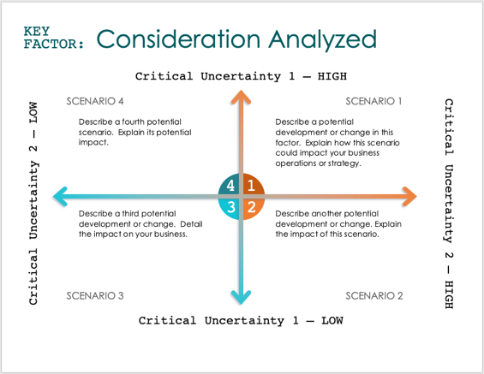
For each factor, consider the most relevant and significant scenarios that could occur, and analyze their potential impacts on your business. This exercise helps in strategic planning, risk management, and decision-making, allowing you to prepare for various possible future developments.
Scenario Analysis Axis Template Instructions

Critical Uncertainty 1 – LOW
Critical Uncertainty 1 – HIGH
Critical Uncertainty 2 – HIGH
Critical Uncertainty 2 – LOW
4
3
1
2
SCENARIO 1
Describe a potential development or change in this factor. Explain how this scenario could impact your business operations or strategy.
SCENARIO 2
Describe another potential development or change. Explain the impact of this scenario.
SCENARIO 4
Describe a fourth potential scenario. Explain its potential impact.
SCENARIO 3
Describe a third potential development or change. Detail the impact on your business.
Consideration Analyzed
KEY
FACTOR:
Critical Uncertainty 1 – LOW
Critical Uncertainty 1 – HIGH
Critical Uncertainty 2 – HIGH
Critical Uncertainty 2 – LOW
4
3
1
2
SCENARIO 1
Describe a potential development or change in this factor. Explain how this scenario could impact your business operations or strategy.
SCENARIO 2
Describe another potential development or change. Explain the impact of this scenario.
SCENARIO 4
Describe a fourth potential scenario. Explain its potential impact.
SCENARIO 3
Describe a third potential development or change. Detail the impact on your business.
Consideration Analyzed
KEY
FACTOR:
Critical Uncertainty 1 – LOW
Critical Uncertainty 1 – HIGH
Critical Uncertainty 2 – HIGH
Critical Uncertainty 2 – LOW
4
3
1
2
SCENARIO 1
Describe a potential development or change in this factor. Explain how this scenario could impact your business operations or strategy.
SCENARIO 2
Describe another potential development or change. Explain the impact of this scenario.
SCENARIO 4
Describe a fourth potential scenario. Explain its potential impact.
SCENARIO 3
Describe a third potential development or change. Detail the impact on your business.
Consideration Analyzed
KEY
FACTOR:
Critical Uncertainty 1 – LOW
Critical Uncertainty 1 – HIGH
Critical Uncertainty 2 – HIGH
Critical Uncertainty 2 – LOW
4
3
1
2
SCENARIO 1
Describe a potential development or change in this factor. Explain how this scenario could impact your business operations or strategy.
SCENARIO 2
Describe another potential development or change. Explain the impact of this scenario.
SCENARIO 4
Describe a fourth potential scenario. Explain its potential impact.
SCENARIO 3
Describe a third potential development or change. Detail the impact on your business.
Consideration Analyzed
KEY
FACTOR:
DISCLAIMER

Any articles, templates, or information provided by Smartsheet on the website are for reference only. While we strive to keep the information up to date and correct, we make no representations or warranties of any kind, express or implied, about the completeness, accuracy, reliability, suitability, or availability with respect to the website or the information, articles, templates, or related graphics contained on the website. Any reliance you place on such information is therefore strictly at your own risk.

