Microsoft Word Cause and Effect Flowchart Template
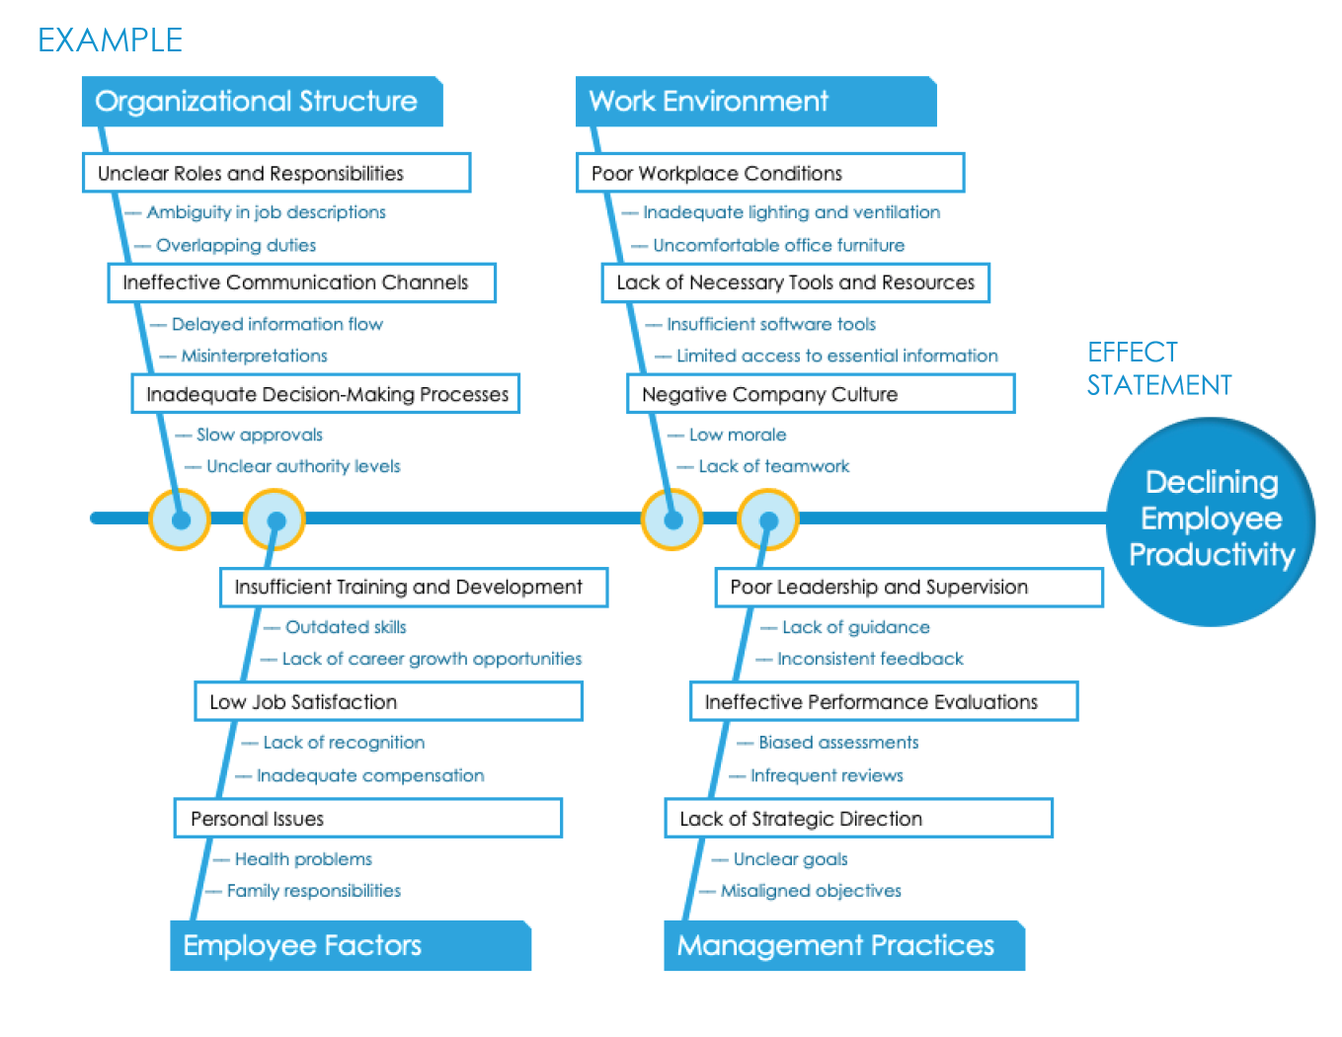

When to Use This Template: Use this template — also known as the fishbone or Ishikawa diagram — when you need to thoroughly investigate the root causes of a specific problem or quality defect. This template is especially valuable in quality assurance processes, project management, and product design, where you need to identify underlying issues to resolve problems.
Notable Template Features: This template organizes potential causes into major categories to systematically explore and visualize the sources of variability in a process. After identifying each “bone,” the template prompts you to explore the factors that might contribute to the problem. This helps teams pinpoint specific areas for improvement.

PRIMARY CAUSE
Cause 2
Primary Sub-Cause
Primary Sub-Cause
Primary Sub-Cause
Primary Sub-Cause
Primary Sub-Cause
Primary Sub-Cause
–– Secondary Sub-Cause

–– Secondary Sub-Cause
–– Example: Methods, materials, environment
–– Secondary Sub-Cause
–– Secondary Sub-Cause
–– Secondary Sub-Cause
–– Secondary Sub-Cause
–– Secondary Sub-Cause
–– Example: Methods, materials, environment

–– Secondary Sub-Cause

–– Secondary Sub-Cause
–– Secondary Sub-Cause
Cause 3
Cause 4
Primary Sub-Cause
Primary Sub-Cause
Primary Sub-Cause
Primary Sub-Cause
Primary Sub-Cause
Primary Sub-Cause
Effect Statement
Text
–– Secondary Sub-Cause

–– Secondary Sub-Cause
–– Example: Methods, machines, manpower

–– Secondary Sub-Cause
–– Secondary Sub-Cause
–– Secondary Sub-Cause
–– Secondary Sub-Cause
–– Secondary Sub-Cause
–– Secondary Sub-Cause

–– Secondary Sub-Cause
–– Secondary Sub-Cause
–– Example: Methods, machines, manpower

DISCLAIMER

Any articles, templates, or information provided by Smartsheet on the website are for reference only. While we strive to keep the information up to date and correct, we make no representations or warranties of any kind, express or implied, about the completeness, accuracy, reliability, suitability, or availability with respect to the website or the information, articles, templates, or related graphics contained on the website. Any reliance you place on such information is therefore strictly at your own risk.

