Microsoft Word Cross-Functional Flowchart Template
When to Use This Template: Utilize the cross-functional flowchart template when you need a detailed analysis of how different departments interact and contribute to the overall project workflow. This template is essential for complex projects that involve multiple teams or stakeholders, when you need clarity about how their functions integrate.

Notable Template Features: This template includes horizontal or vertical lanes for each department or function. This feature allows you to clearly visualize how individual tasks move through different parts of the organization, so you can effectively map out the roles in each department. This template also allows you to highlight interactions and dependencies between each role and task.

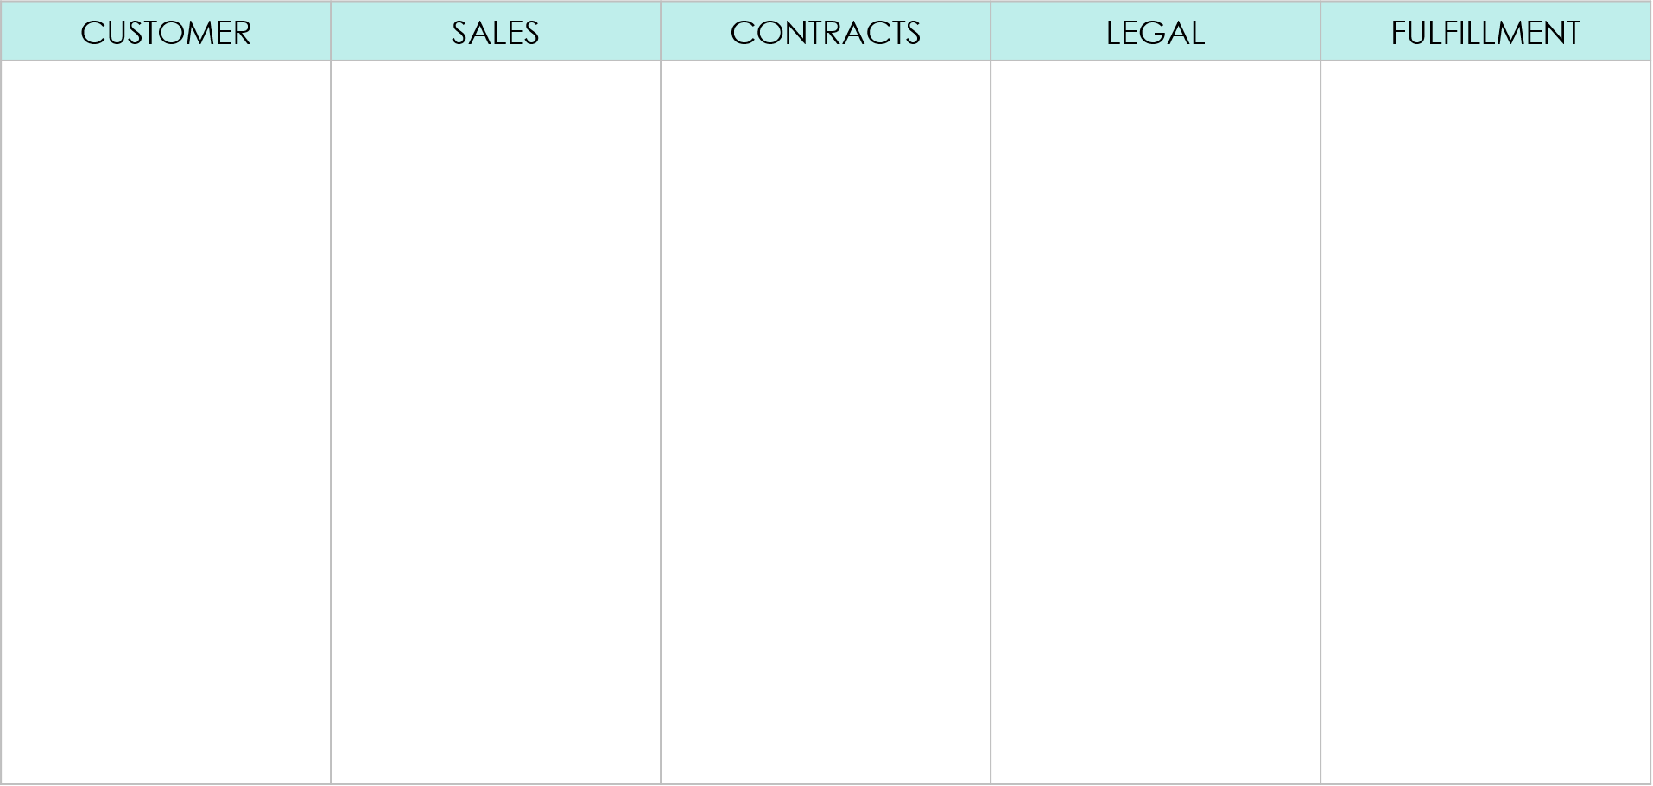
EXAMPLE CROSS-FUNCTIONAL FLOWCHART
Ships order to customer
Drafts contract for special pricing and terms
Reviews and approves contract
YES
NO
Finalizes sale and forwards details to fulfillment
Is special pricing needed?
Signs contract
Reviews order details and confirms feasibility
Submits custom order details via website
Initiates request for customer order
Receives and confirms custom order
Prepares custom order for shipment
Select and combined the elements on Page 3 of this template to create your own flowchart.
DEPARTMENT | DEPARTMENT  FLOWCHART ELEMENTS | DEPARTMENT | DEPARTMENT | DEPARTMENT
COMMENTS AND NOTES:
Additional information…
LEGEND

INTERACTION
INTERACTION
DECISION POINT
END POINT
Select and combined the elements to create your own flowchart.
FLOWCHART ELEMENTS
START
PROCESS STEP
Input / Output
Data Input
DECISION POINT
YES
NO
PROCESS STEP
PROCESS STEP
DECISION POINT

YES
NO
Data Input
PROCESS STEP
Input / Output

DISCLAIMER

Any articles, templates, or information provided by Smartsheet on the website are for reference only. While we strive to keep the information up to date and correct, we make no representations or warranties of any kind, express or implied, about the completeness, accuracy, reliability, suitability, or availability with respect to the website or the information, articles, templates, or related graphics contained on the website. Any reliance you place on such information is therefore strictly at your own risk.

