Microsoft Word Decision Flowchart Template
When to Use This Template:
Use this template whenever your team needs to make a critical decision. It is particularly useful in strategic planning sessions, risk management meetings, or any situation where you need to evaluate the consequences of different choices, so you can guide stakeholders toward informed decisions.
Notable Template Features:
This template includes decision points and branching paths so that you can explore various scenarios. The layout helps you visualize and analyze the impact of each potential choice.
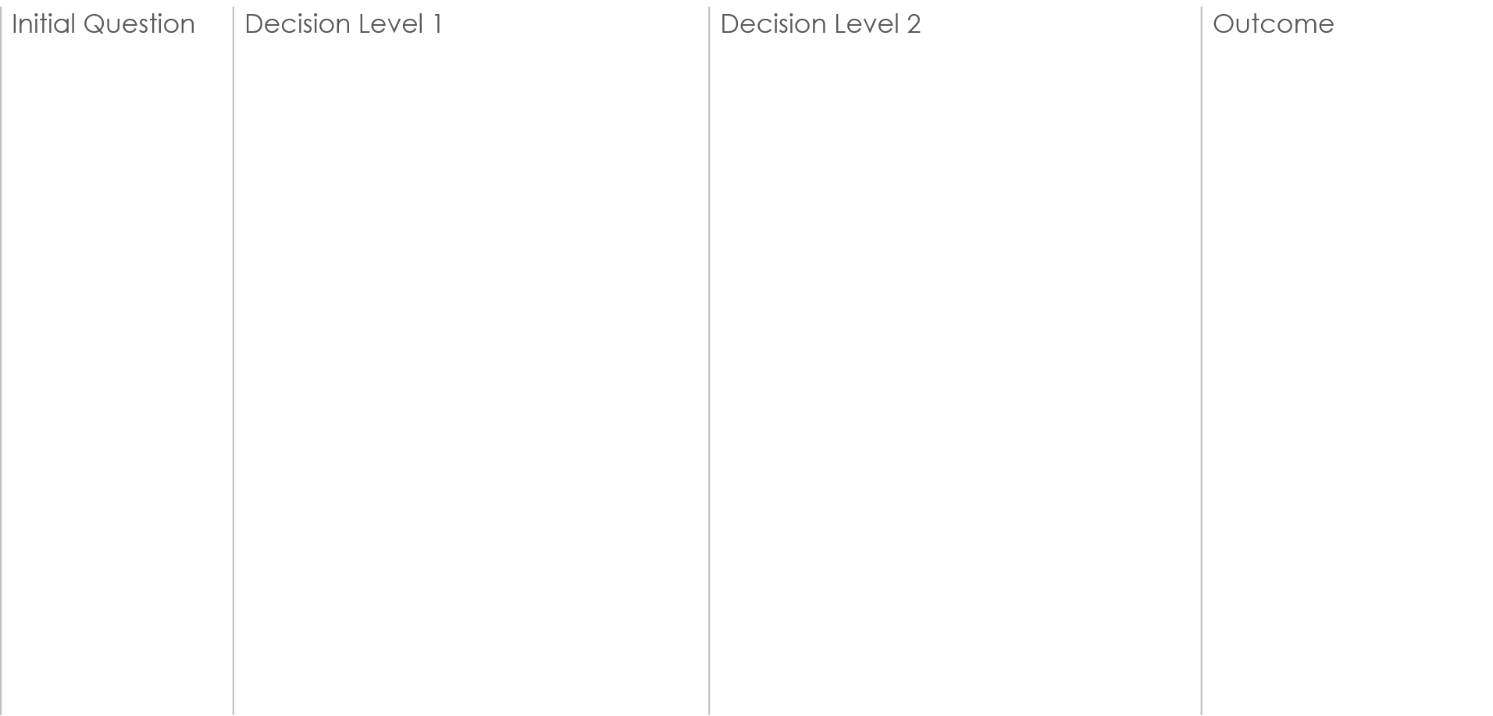
Decision B2:
Will it improve user satisfaction?
NO
NO
NO
Decision A1:
Do we have the necessary
resources?
Decision B1:
Is it technically feasible?
Decision C1:
Is it a core feature or an enhancement?
Reconsider based on ROI
Conduct further research
Reassess feature scope and dependencies
Plan for resource acquisition
Seek customer feedback for alternatives
Schedule for future sprint
Prioritize development
Implement in next release cycle
Proceed with integration testing
Begin development phase
Validate with prototype
Fast-track development
YES
YES
YES
Decision A2:
Will it provide a competitive advantage?
NO
YES
NO
YES
NO
YES
NO
YES
NO
YES
EXAMPLE TEMPLATE
INPUT
Decision C:
Can we build it within the budget?
Decision B:
Do customers demand this feature?
Decision A:
Is the feature aligned with our product roadmap?
NO
YES
Should we develop the new feature?
Decision C2:
Does it integrate well with the existing features?
Explore alternative solutions
Do not proceed with development
Reevaluate at next roadmap meeting
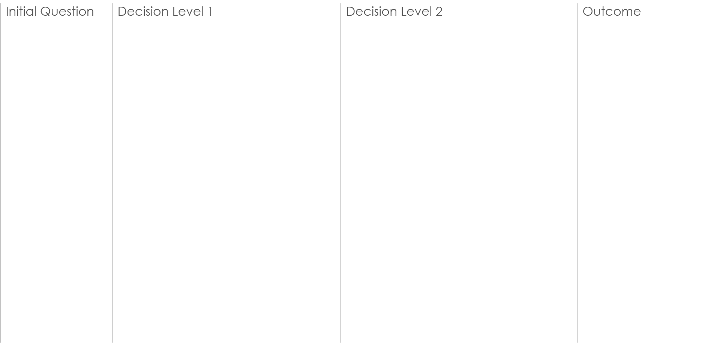
Decision C
Decision B
Decision A
Decision B2
Decision C2
Question
NO
Description
Description
NO
NO
Description
Decision A1
Decision B1
Decision C1
Description

Description

Description

Description

Description

Description

Description

Description

Description

Description
Description

Description

YES
YES
YES
Decision A2
NO
YES
NO
YES
NO
YES
NO
YES
NO
YES
NO
YES

COMMENTS AND NOTES:
Additional information…
LEGEND
INPUT / OUTPUT
DECISION POINTS
PROCESS STEP
STARTING QUESTION
INPUT / OUTPUT
DISCLAIMER

Any articles, templates, or information provided by Smartsheet on the website are for reference only. While we strive to keep the information up to date and correct, we make no representations or warranties of any kind, express or implied, about the completeness, accuracy, reliability, suitability, or availability with respect to the website or the information, articles, templates, or related graphics contained on the website. Any reliance you place on such information is therefore strictly at your own risk.

