RISK SCENARIO PLANNING TEMPLATE

PROJECT OWNERSHIP
PROJECT
NAME
PROJECT OVERVIEW
PROJECT MANAGER
CONTACT INFO
PHONE | EMAIL | MAILING ADDRESS

VERSION
VERSION |  | DATE | AUTHOR
REASON
SECTIONS IMPACTED
SECTION TITLE |  | AMENDMENT
DISTRIBUTION
DELIVERY METHOD |  | ISSUE DATE | ISSUED TO

EXECUTIVE SUMMARY
RISK ANALYSIS AND EVALUATION PROCESS
DEVELOPMENT OF RISK PREVENTION MITIGATION STRATEGIES PROCESS
REVIEW SCHEDULE, PROCESS, AND RESPONSIBLE PARTIES
RISK MANAGEMENT ROLES AND RESPONSIBILITIES
NAME | ROLE | RESPONSIBILITIES
RISK REPORTING PROCESS

RISK ASSESSMENT
RISK IDENTIFICATION
RISK OVERVIEW |  | EVENT OR THREAT TRIGGERS
RISK REGISTER
IDENTIFIED RISK | CURRENT STATUS | RISK MITIGATION STRATEGIES

CONTINGENCY ANALYSIS AND EVALUATION
Complete the following for each IDENTIFIED RISK. See MATRIX.
IDENTIFIED RISK | RISK GRADE | POTENTIAL IMPACT
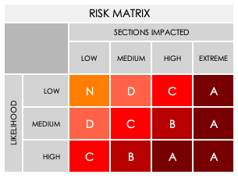

MITIGATION
Complete the following for each IDENTIFIED RISK. See MITIGATION CHART below.
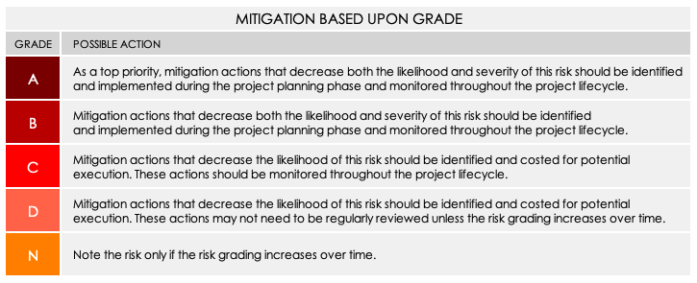

IDENTIFIED RISK
GRADE |  | MITIGATION ACTION: Preventative or Contingency?
BUDGETARY IMPLICATIONS
STAKEHOLDERS RESPONSIBLE
IDENTIFIED RISK
GRADE |  | MITIGATION ACTION: Preventative or Contingency?
BUDGETARY IMPLICATIONS
STAKEHOLDERS RESPONSIBLE
IDENTIFIED RISK
GRADE |  | MITIGATION ACTION: Preventative or Contingency?
BUDGETARY IMPLICATIONS
STAKEHOLDERS RESPONSIBLE
IDENTIFIED RISK
GRADE |  | MITIGATION ACTION: Preventative or Contingency?
BUDGETARY IMPLICATIONS
STAKEHOLDERS RESPONSIBLE

RISK MONITORING
REVIEW OF RISKS AND ISSUES | check for issues that may have escalated
REVIEW FREQUENCY
PARTIES RESPONSIBLE FOR REVIEWING
MONITORING
MONITORING FREQUENCY
PARTIES RESPONSIBLE FOR MONITORING
REPORTING
REPORTING FREQUENCY
PARTIES RESPONSIBLE FOR REPORTING

DISCLAIMER

Any articles, templates, or information provided by Smartsheet on the website are for reference only. While we strive to keep the information up to date and correct, we make no representations or warranties of any kind, express or implied, about the completeness, accuracy, reliability, suitability, or availability with respect to the website or the information, articles, templates, or related graphics contained on the website. Any reliance you place on such information is therefore strictly at your own risk.

