STRATEGIC MANAGEMENT SCENARIO
PLANNING TEMPLATE
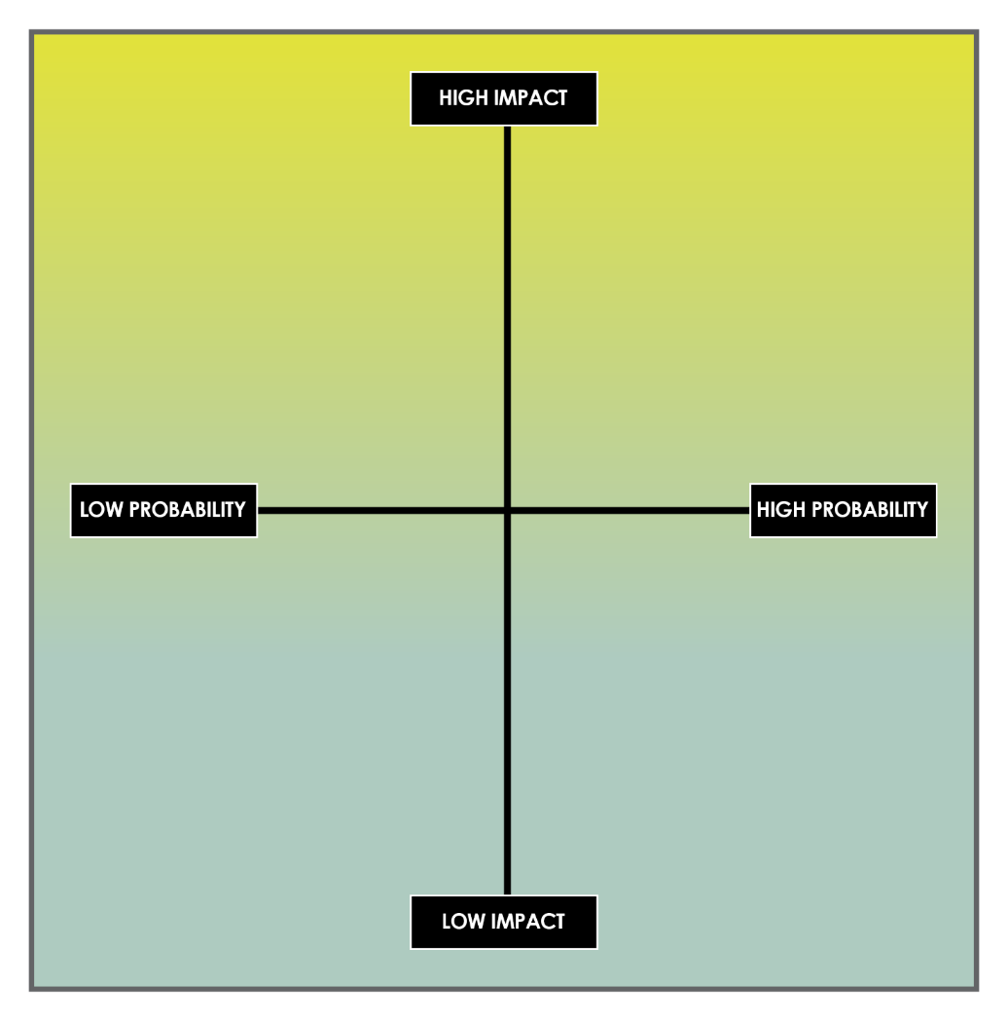
By helping strategic managers adjust the nomenclature and focus of each quadrant, this template encourages these leaders to think differently about potential scenarios and their implications for the organization. This approach supports a nuanced understanding of the strategic environment, empowering you to craft responsive and resilient strategies.
FLEETING
ANOMALY
STRATEGIC
EVOLUTION
PIVOTAL TRANSFORMATION
LEGEND
QUADRANTS
Pivotal Transformation | This quadrant focuses on significant changes that require fundamental adjustments to strategy or operations.
Strategic Evolution | This quadrant emphasizes the implementation of deliberate and thoughtful changes in strategy, so managers can adapt to or anticipate market dynamics.
Fleeting Anomaly | This quadrant highlights events or trends that appear impactful but do not have lasting effects on the strategic landscape.
Gradual Progression | This quadrant focuses on making continuous, small-scale improvements or adjustments in response to ongoing market feedback.
DIRECTIONAL POINTS
High Impact | This directional point denotes scenarios that have significant effects on the organization’s performance or strategy.
High Probability | This directional point represents scenarios that are very likely to appear on the planning horizon.
Low Probability | This directional point refers to scenarios that probably won't occur but still require consideration.
Low Impact | This directional point describes scenarios that you expect to have minimal influence on the organization’s trajectory.

DISCLAIMER

Any articles, templates, or information provided by Smartsheet on the website are for reference only. While we strive to keep the information up to date and correct, we make no representations or warranties of any kind, express or implied, about the completeness, accuracy, reliability, suitability, or availability with respect to the website or the information, articles, templates, or related graphics contained on the website. Any reliance you place on such information is therefore strictly at your own risk.

