WAY GAMING SCENARIO
PLANNING TEMPLATE
Use this strategic simulation outline with seven stages, each
accompanied by brief instructions to help your team explore
and test responses to various future scenarios.
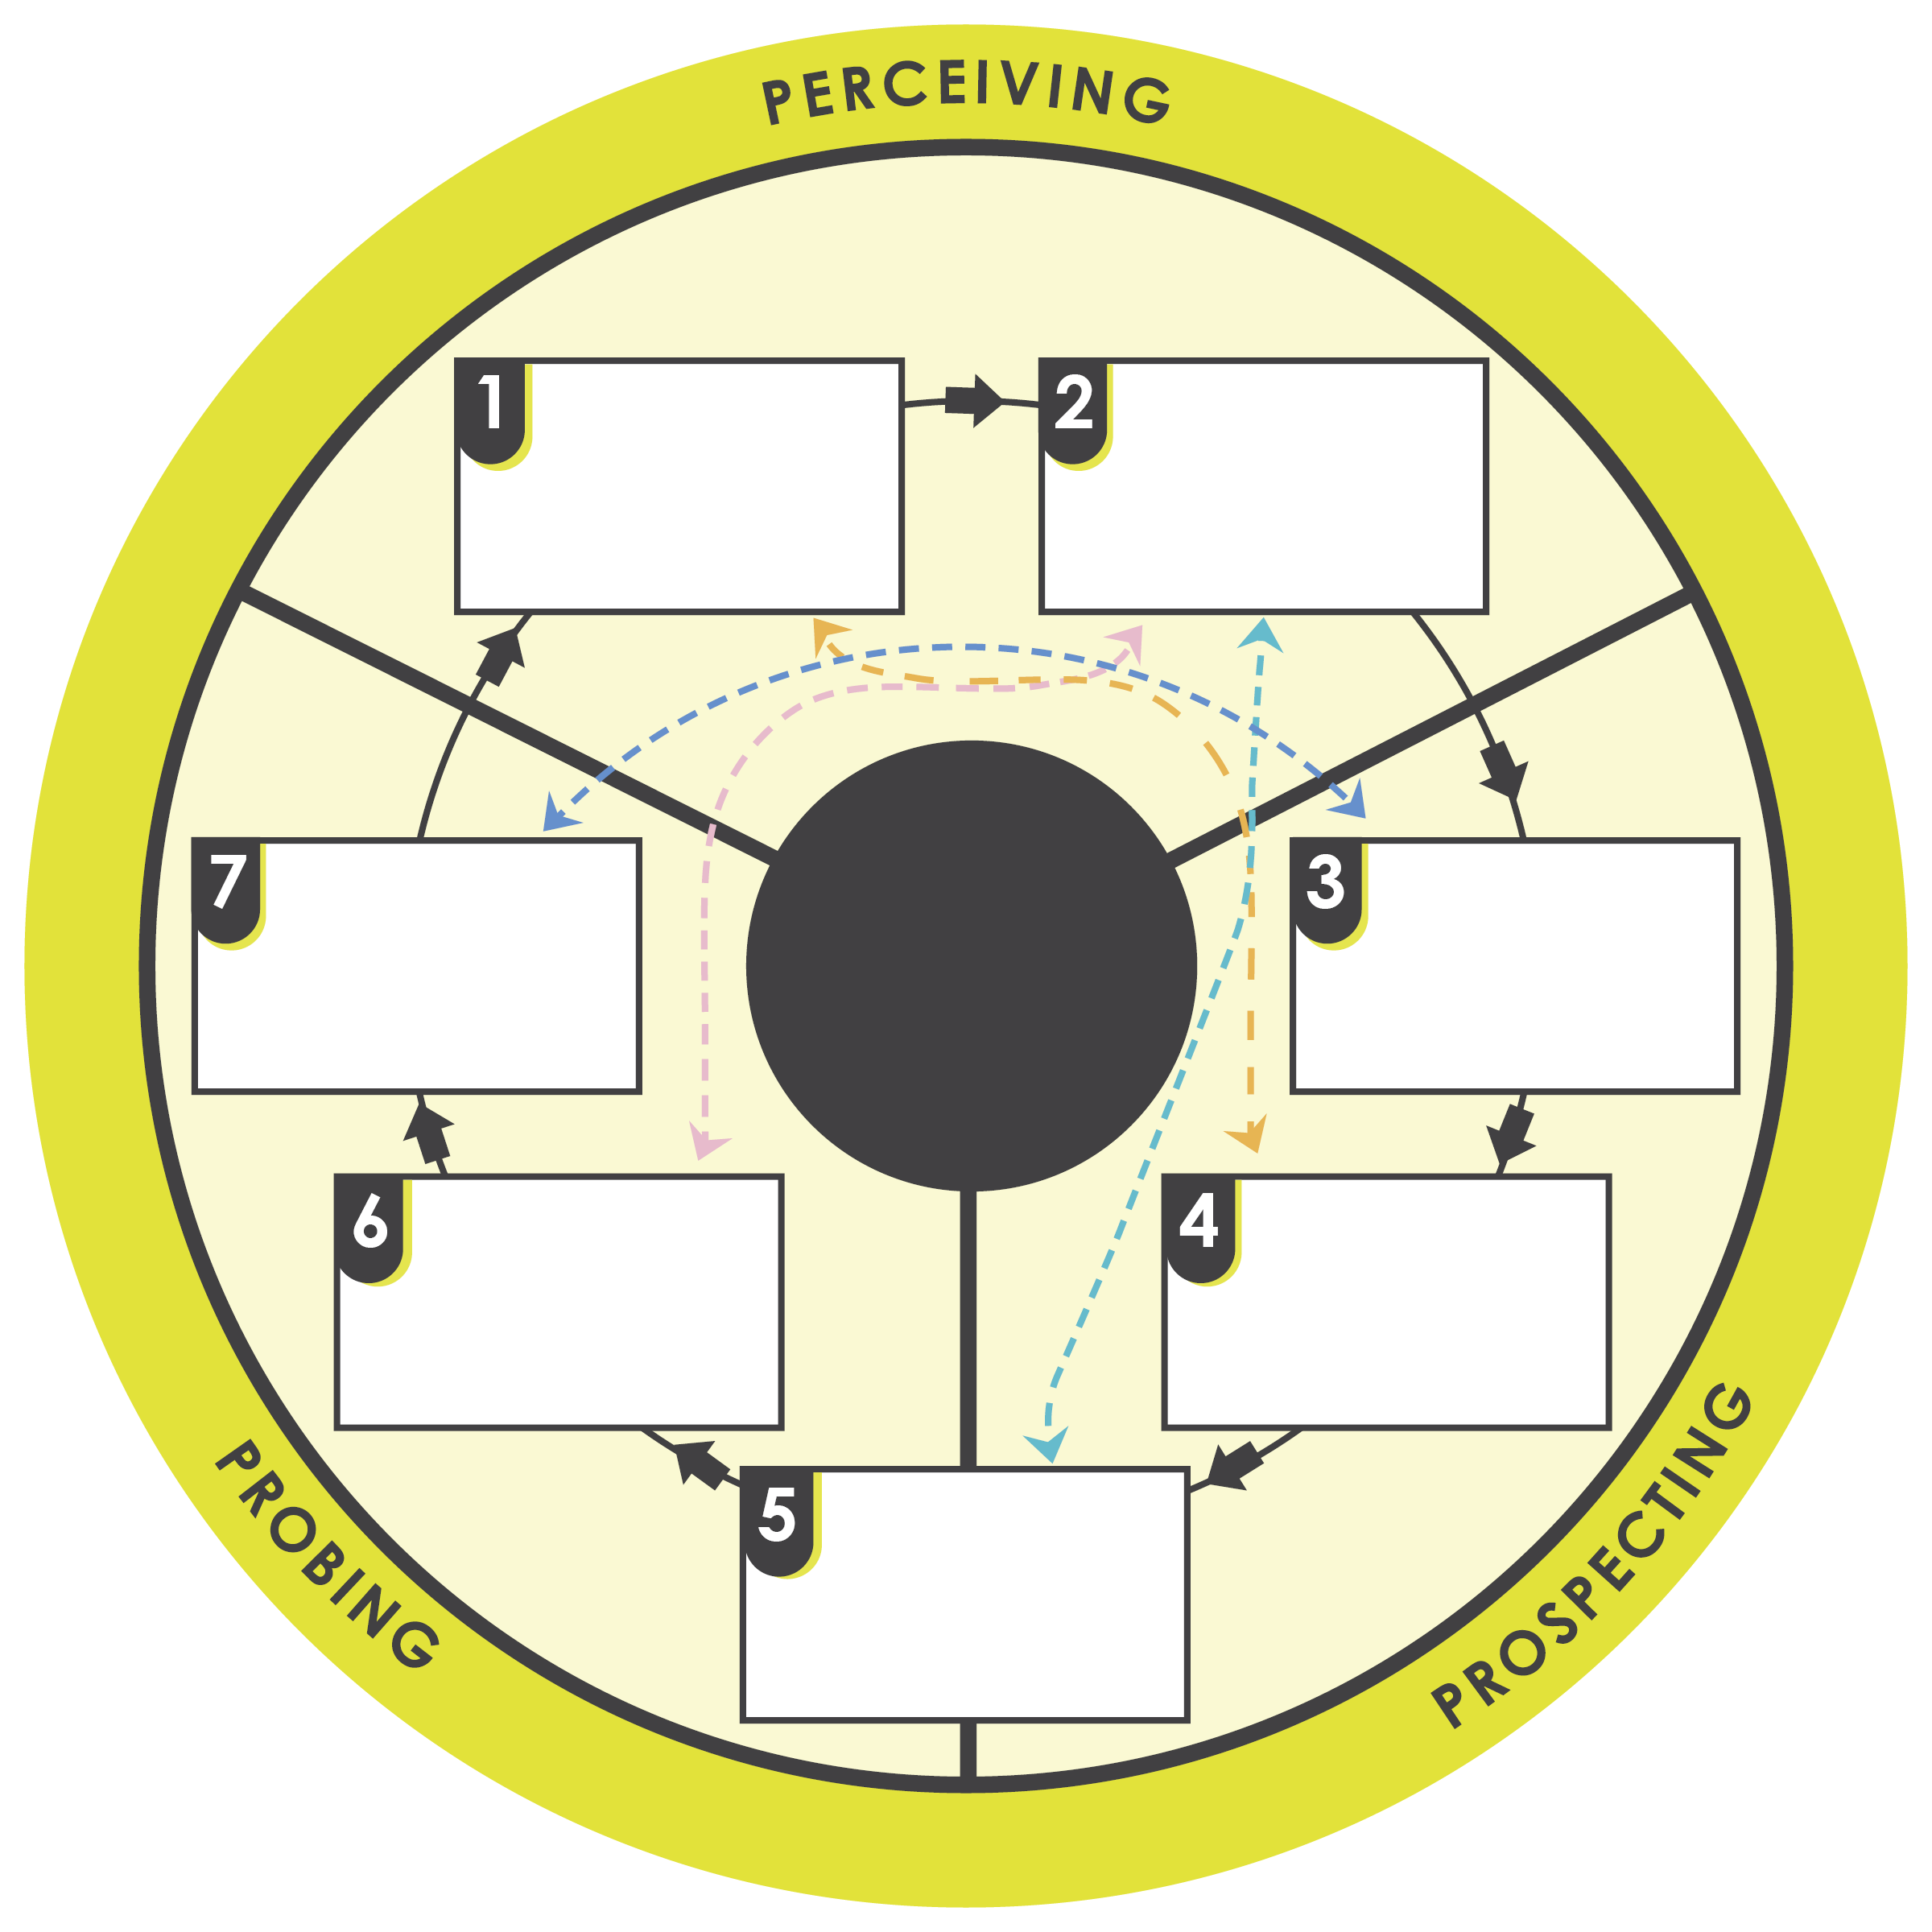
Simulation Execution: Run the simulation, allowing teams to implement their strategies within the structured, game-like environment. Encourage interaction and decision-making based on the evolving scenario dynamics.

WAY GAMING SCENARIO PLANNING PROCESS

Role Assignment: For the simulation, assign roles to team members (e.g., scenario stakeholders, decision-makers, and external entities) in order to mimic real-world dynamics.

Strategy Formulation: Develop strategies and responses for each scenario. Encourage creativity and strategic thinking to address the challenges presented.

Scenario Briefing: Provide detailed briefings to the team on each scenario, including background information, potential impacts, and key challenges to address.

Debrief and Analysis: After the simulation, conduct a thorough debriefing session. Analyze decisions made, strategies implemented, and the outcomes. Discuss what worked, what didn’t, and why.
Debrief and Analysis: After the simulation, conduct a thorough debriefing session. Analyze decisions made, strategies implemented, and the outcomes. Discuss what worked, what didn’t, and why.

Team Assembly: Assemble a diverse team with representatives from various functions within your organization to ensure a comprehensive perspective on each scenario.

Scenario Identification: Identify and articulate specific scenarios you want to explore. These should cover a range of probable to potential future states affecting your organization.
DISCLAIMER

Any articles, templates, or information provided by Smartsheet on the website are for reference only. While we strive to keep the information up to date and correct, we make no representations or warranties of any kind, express or implied, about the completeness, accuracy, reliability, suitability, or availability with respect to the website or the information, articles, templates, or related graphics contained on the website. Any reliance you place on such information is therefore strictly at your own risk.

