BRAND STYLE GUIDE
PRESENTATION
TEMPLATE – VERTICAL

BRAND STYLE GUIDE
ORGANIZATION NAME

YOUR
LOGO

Street Address
City, State and Zip

webaddress.com

Version 0.0.0

00/00/0000

©20XX. All Rights Reserved Your Organization.

©20XX. All Rights Reserved Your Organization.

sales@smartsheet.com
(844) 324-2360
smartsheet.com
/smartsheet
/company/smartsheet-com
/@smartsheet
/smartsheet
/smartsheet
table of contents
1. Usage Guidelines 4
2. Mark Usage DO’s 5
3. Mark Usage DON’Ts 6
4. Colors 7
5. Fonts 8
6. Logo 9
7. Clearance 10
8. Incorrect Usage 11

Usage Guidelines

Mark Usage DO’s
- Do always use proper trademark form and spelling.
- Do distinguish trademarks from surrounding text with appropriate capitalization
(initial letters capitalized or all letters capitalized), italics, or quotation marks.

Mark Usage DON’Ts
- Don’t modify a trademark to a plural form.
- Don’t alter a trademark in any way, including through visual identifiers or unapproved fonts.

Colors

Hex:
RGB:
CMYK:
Pantone:
#000000
0/ 0 / 0
0 / 0 / 0 / 0
XXXX
Hex:
RGB:
CMYK:
Pantone:
#000000
0/ 0 / 0
0 / 0 / 0 / 0
XXXX
Lush Green
Power Blue
Bronze Beach
#000000
0/ 0 / 0
0 / 0 / 0 / 0
XXXX
Hex:
RGB:
CMYK:
Pantone:
Golden Sun
Hex:
RGB:
CMYK:
Pantone:
#000000
0/ 0 / 0
0 / 0 / 0 / 0
XXXX

Fonts
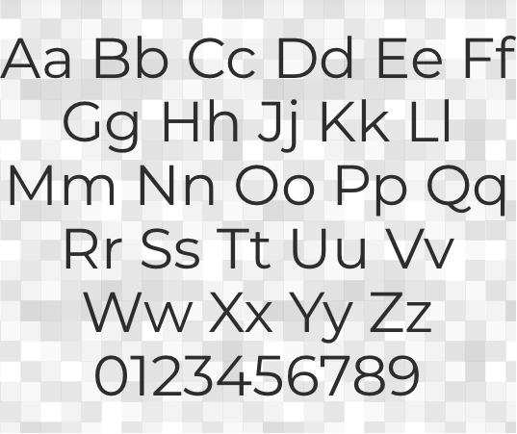
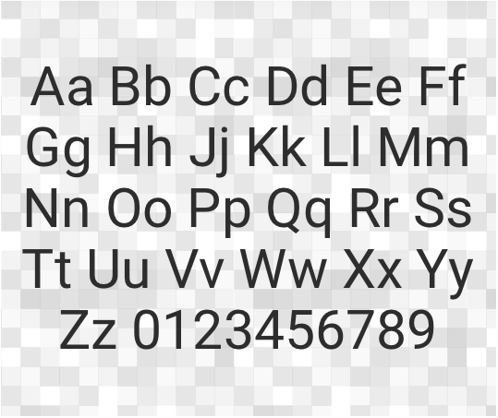
Roboto
Montserrat

Logo
Below are all the accepted treatments of the logo.
Horizontal Layout

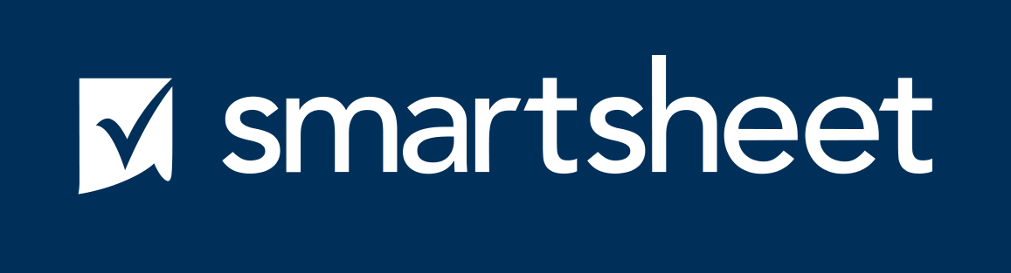
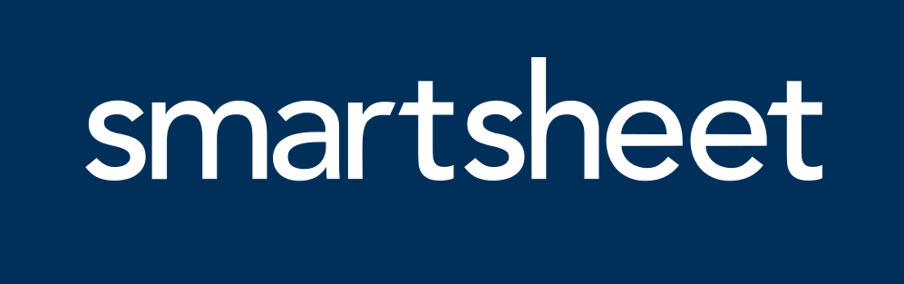
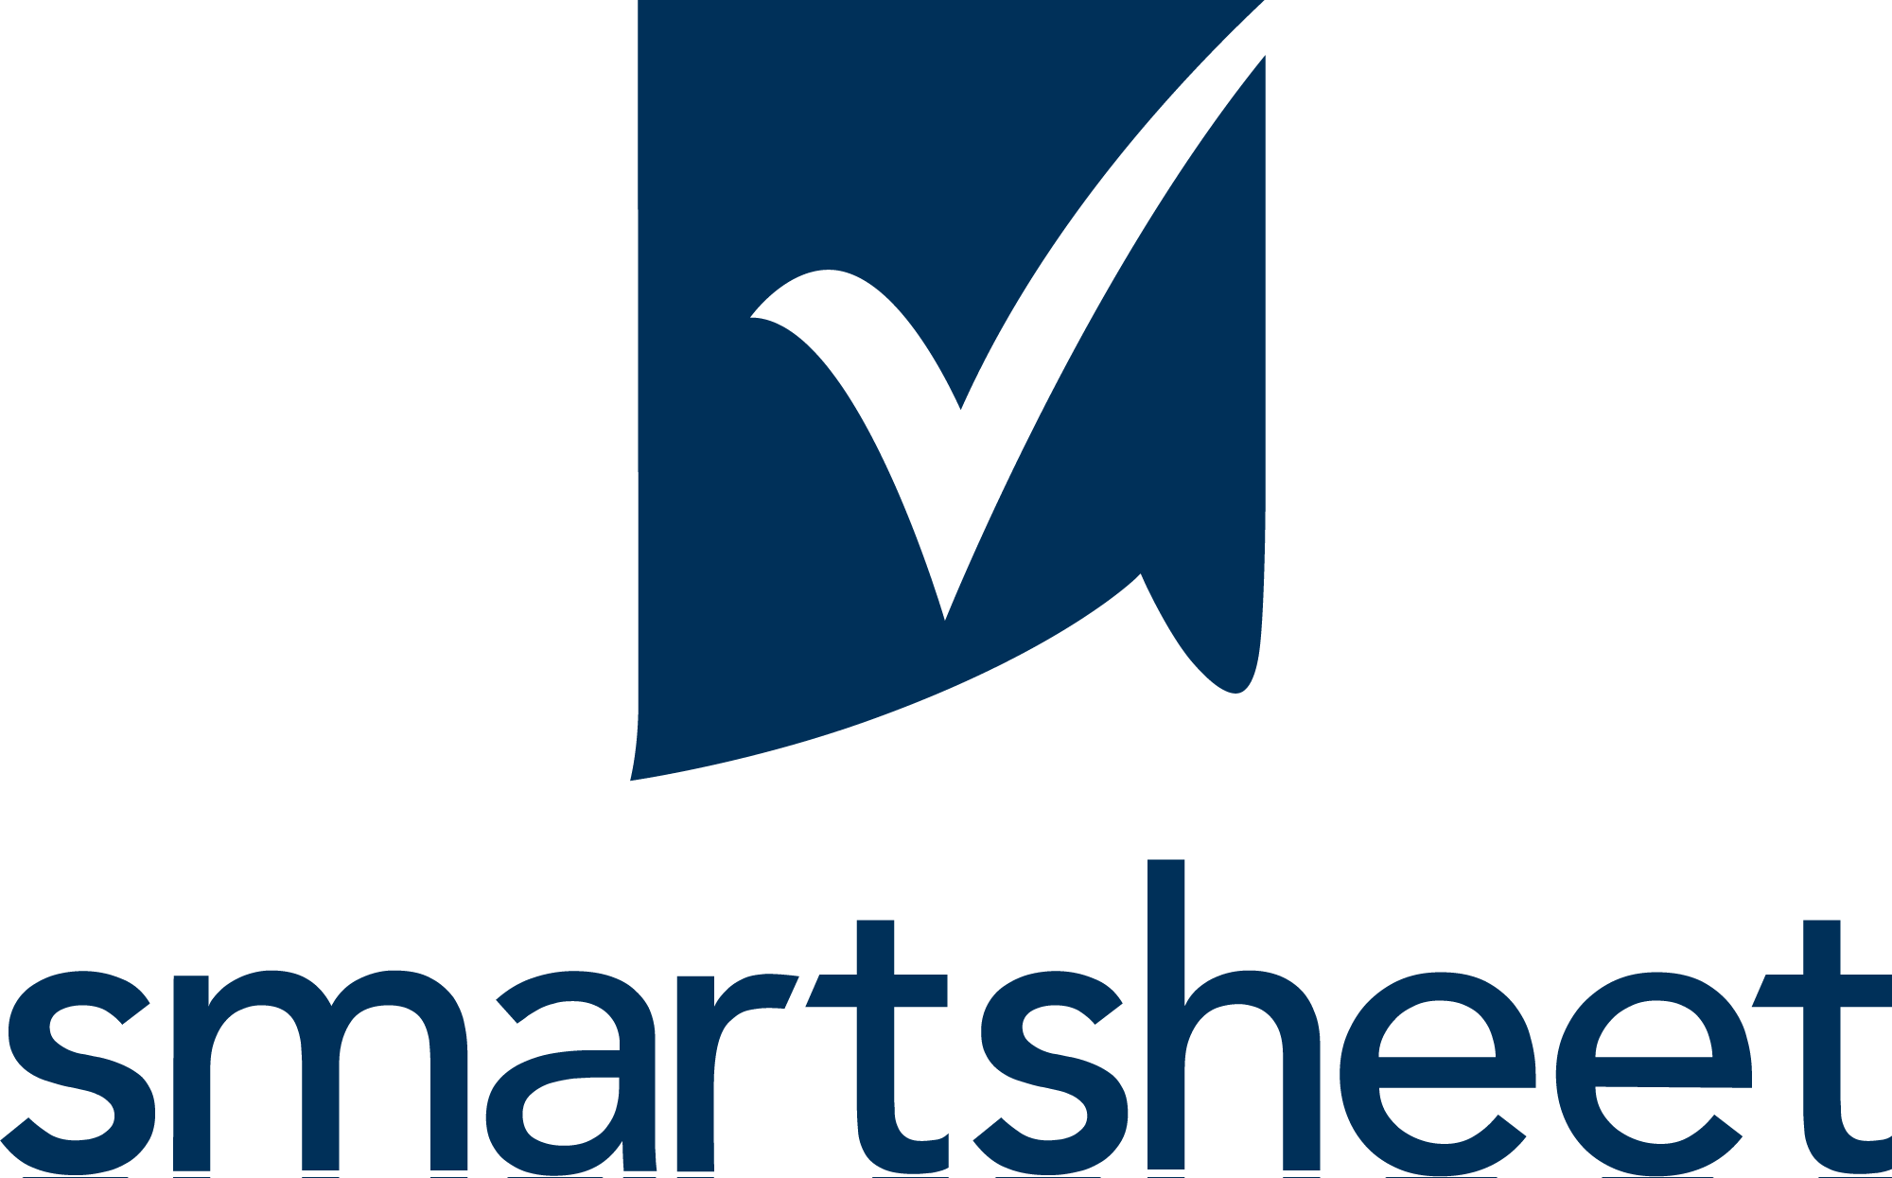
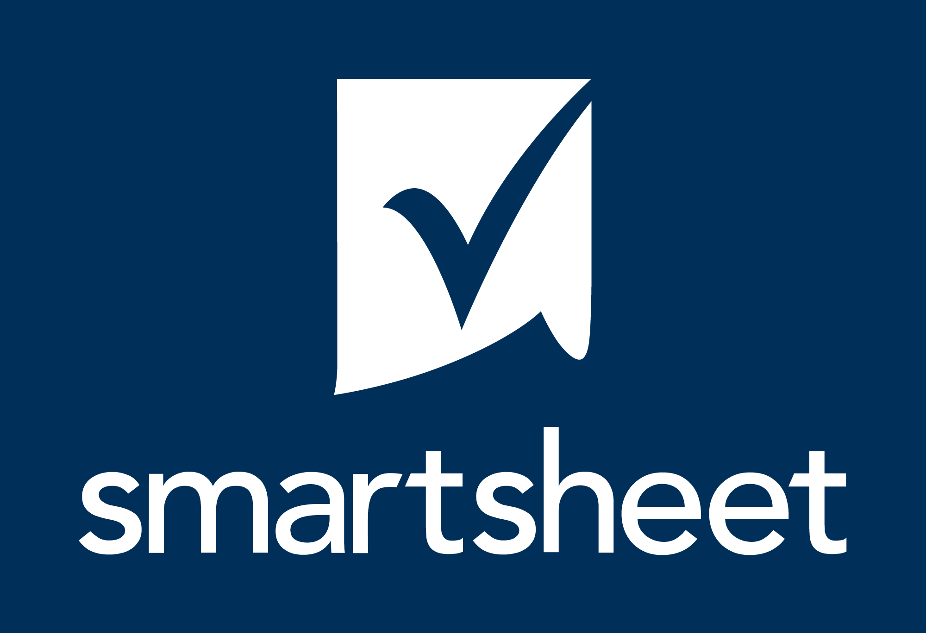
Logomark (icon)
The logotype sans logomark is to be used exclusively within the app.
Wordmark
Vertical Layout

Clearance
Give the logo some room to breathe. The logo should be allowed some clear space around the entire lockup. This will provide proper spacing for its character ascenders. Below is the minimum amount of clearance, but more is preferred.

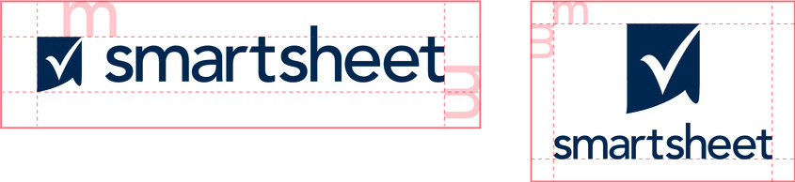

Incorrect Usage
Please use the logos as they are provided in these guidelines. Don’t alter the logo.

Don’t change the colors
Change colors
Skew
Don’t skew or scale disproportionately

Don’t place on complicated backgrounds
Use busy backgrounds
Don’t add drop shadows, strokes, or bevels
Add effects
Don’t change the orientation
Alter orientation
Recreate
Don’t make alterations, additions, or substitutions

DISCLAIMER

Any articles, templates, or information provided by Smartsheet on the website are for reference only. While we strive to keep the information up to date and correct, we make no representations or warranties of any kind, express or implied, about the completeness, accuracy, reliability, suitability, or availability with respect to the website or the information, articles, templates, or related graphics contained on the website. Any reliance you place on such information is therefore strictly at your own risk.

