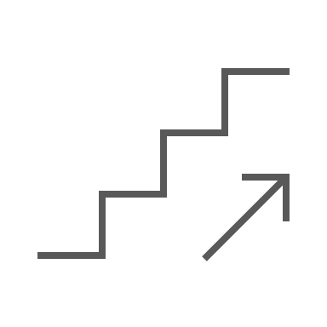
Customer Benefit Ladder Example
Think about where you are on the customer benefit ladder. Your brand increases its potential as you climb the ladder, but you can’t overstep. Customers need to believe your brand’s promise. Once they do, they’ll pay more for your product, and competitors will have a harder time challenging you.
Lindsay Pedersen’s example (below) of Bounce dryer sheets, a new product type introduced in 1975, took time to move up the ladder to the highest-benefit messaging.
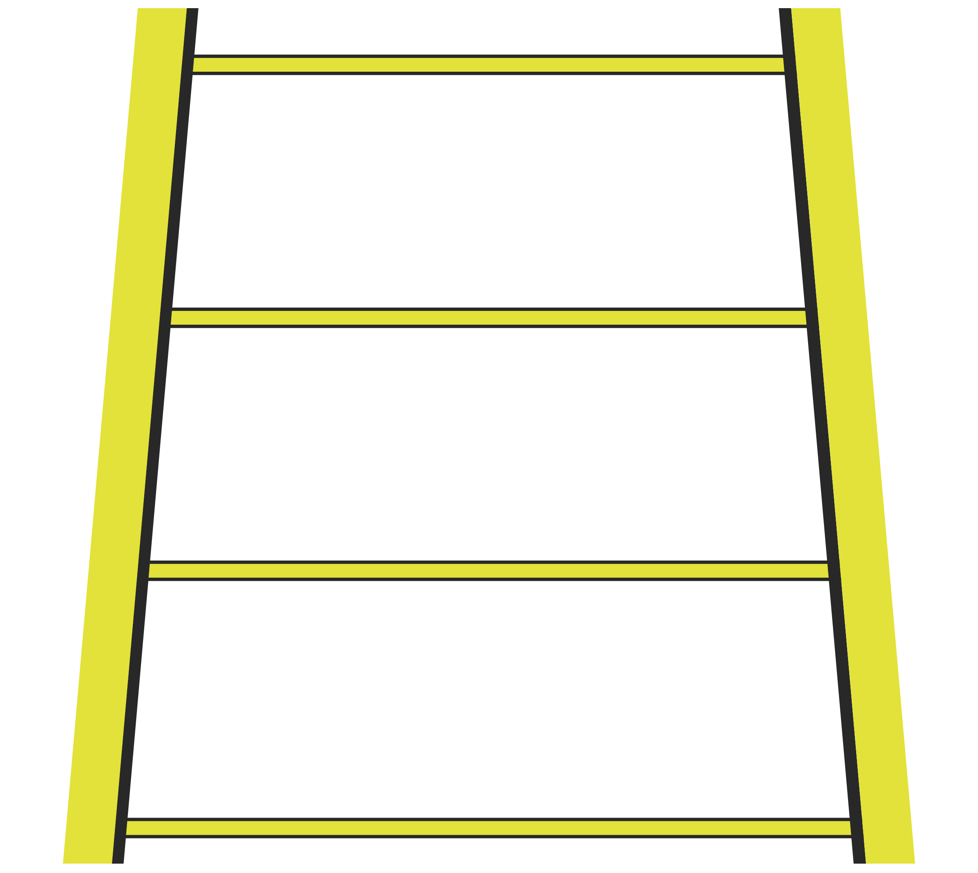

FUNCTIONAL BENEFIT EXAMPLE
Wrinkle-free clothes.
EMOTIONAL BENEFIT EXAMPLE
Enjoy more attractive clothes.
HIGHEST BENEFIT EXAMPLE
Feel pretty.

DISCLAIMER

Any articles, templates, or information provided by Smartsheet on the website are for reference only. While we strive to keep the information up to date and correct, we make no representations or warranties of any kind, express or implied, about the completeness, accuracy, reliability, suitability, or availability with respect to the website or the information, articles, templates, or related graphics contained on the website. Any reliance you place on such information is therefore strictly at your own risk.

