IT Service Desk / ITIL Escalation Matrix Template

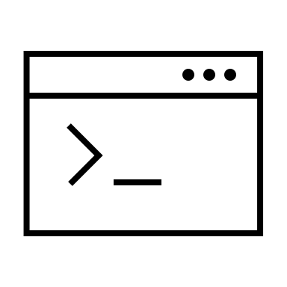
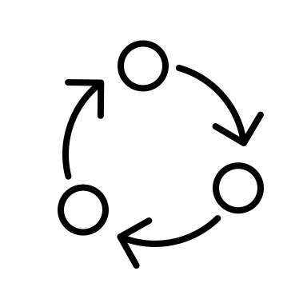
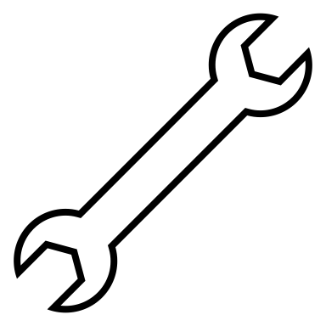
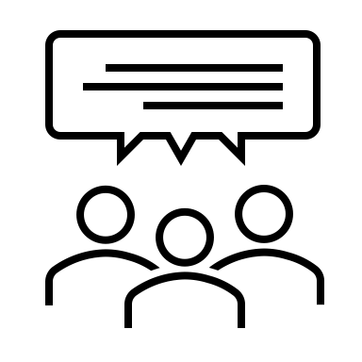
Issue 1
As the initial point of contact for all IT issues, the service desk handles general inquiries and basic troubleshooting.
Tier 2 deals with more complex issues that require specialized knowledge or additional technical skills.
Tier 3 addresses high-level technical challenges involving system infrastructure or deep software problems.
IT Service Desk (Tier 1)
Tier X represents specialized external support or vendor-specific assistance for highly specialized issues.
Tier 2 Support
Tier 3 Support
Tier X Support
Issue 2
Issue 3
Issue 4

DISCLAIMER

Any articles, templates, or information provided by Smartsheet on the website are for reference only. While we strive to keep the information up to date and correct, we make no representations or warranties of any kind, express or implied, about the completeness, accuracy, reliability, suitability, or availability with respect to the website or the information, articles, templates, or related graphics contained on the website. Any reliance you place on such information is therefore strictly at your own risk.

