**](https://www.smartsheet.com/try-it?trp=12184&utm_source=template-word&utm_medium=content&utm_campaign=Value+Stream+Current+State+Map-word-12184&lpa=Value+Stream+Current+State+Map+word+12184)Value Stream Current State Map   
Template**

Use this map to illustrate the current state of a process flow, identify inefficiencies, and show where there is room for improvement in the workflow process.

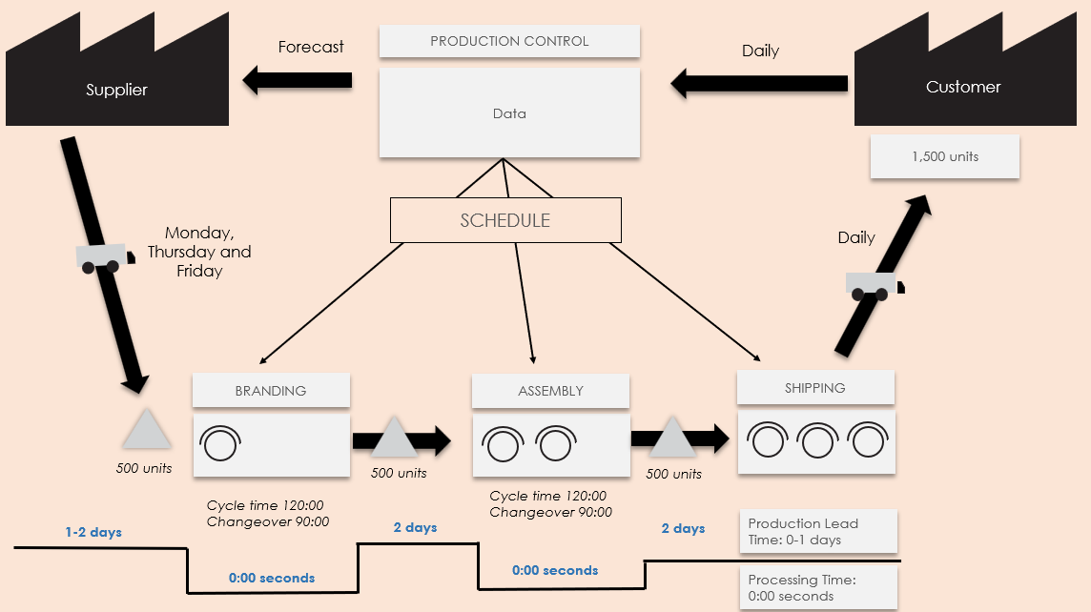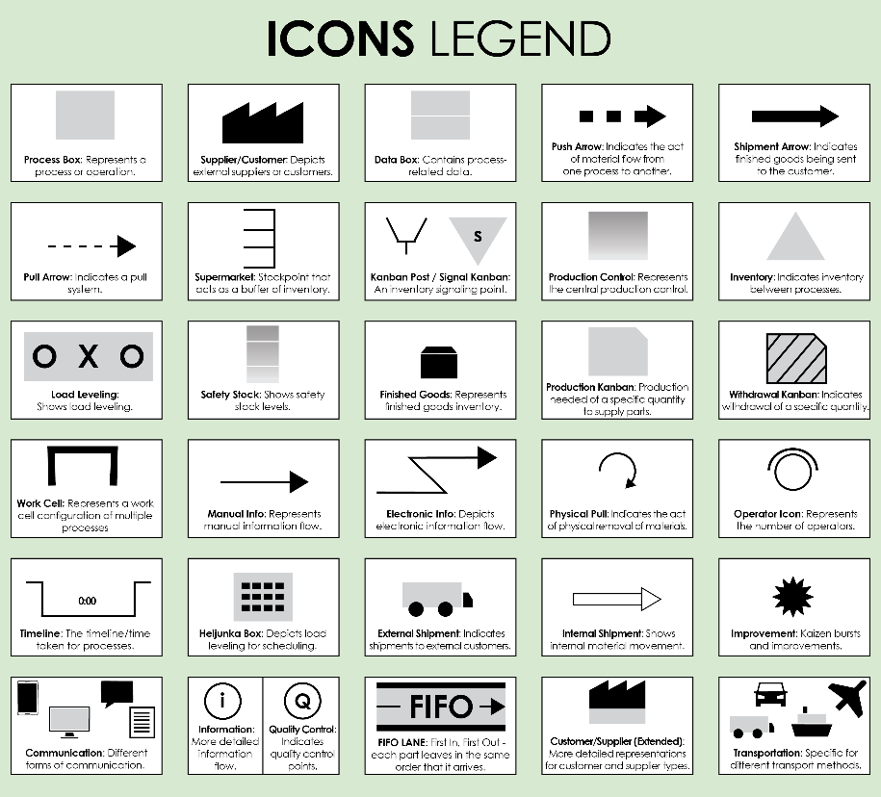

For descriptions, see **VSM Icons Legend** on Page 4 of this document.

To create your own VSM, copy and paste icons from the **VSM Icons** on Page 5 of this document.

NOTES

**Value Stream Current State Map Template**

To create your own VSM, copy and paste icons from the **VSM Icons** on Page 5 of this document.

**Value Stream Current State Map Template Example**

Forecast

*500 units*

*500 units*

*500 units*

*Cycle time 120:00*

*Changeover 90:00*

*Cycle time 120:00*

*Changeover 90:00*

**0:00 seconds**

**0:00 seconds**

Daily

Customer

Supplier

Processing Time:  
0:00 seconds

**2 days**

Production Lead Time: 0-1 days

SCHEDULE

BRANDING

ASSEMBLY

1,500 units

Data

**2 days**

**1-2 days**

SHIPPING

Monday, Thursday and Friday

Daily

PRODUCTION CONTROL

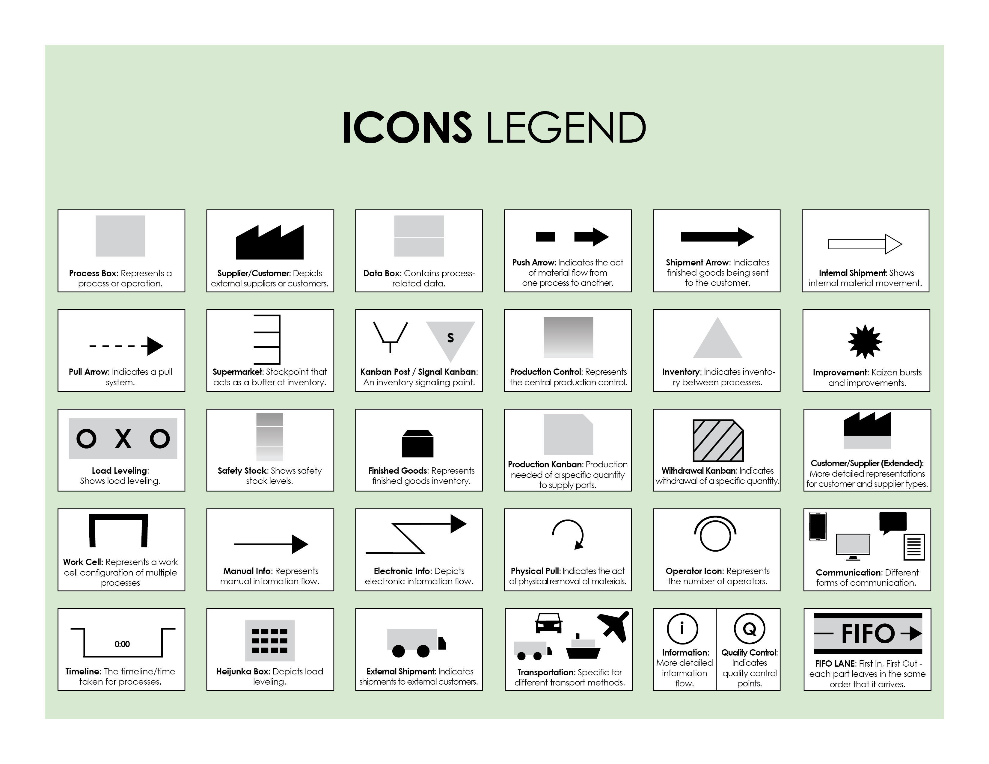

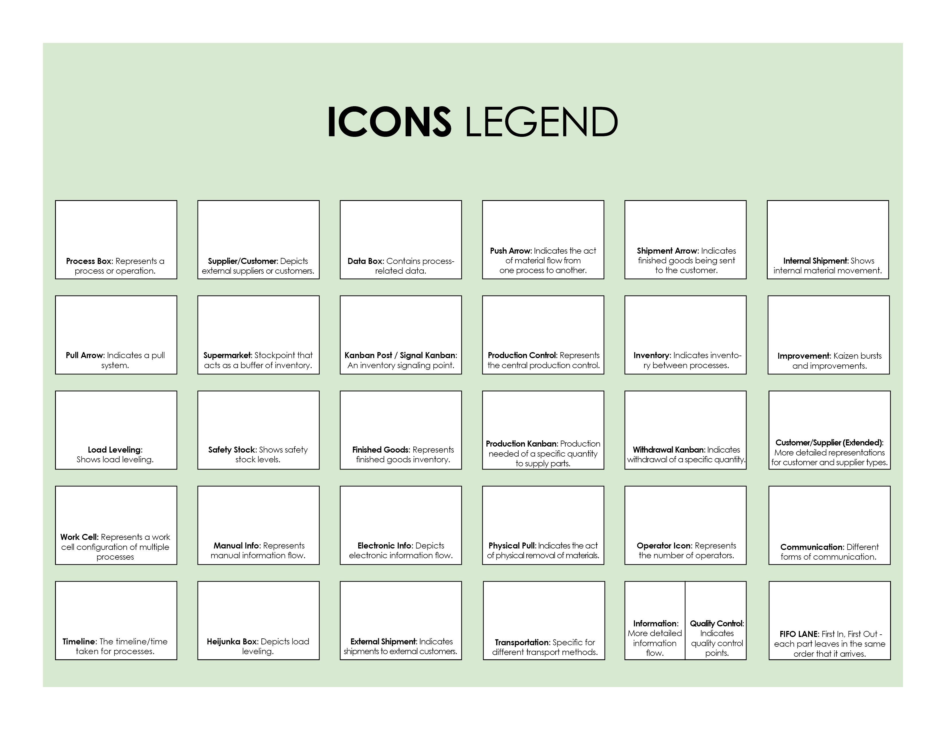

Copy and paste the icons below to create your own VSM.



|  |
| --- |
| **DISCLAIMER**  Any articles, templates, or information provided by Smartsheet on the website are for reference only. While we strive to keep the information up to date and correct, we make no representations or warranties of any kind, express or implied, about the completeness, accuracy, reliability, suitability, or availability with respect to the website or the information, articles, templates, or related graphics contained on the website. Any reliance you place on such information is therefore strictly at your own risk. |