**Microsoft Word   
Automotive  
Work Order   
](https://www.smartsheet.com/try-it?trp=12207&utm_source=template-word&utm_medium=content&utm_campaign=Automotive+Work+Order-word-12207&lpa=Automotive+Work+Order+word+12207)**

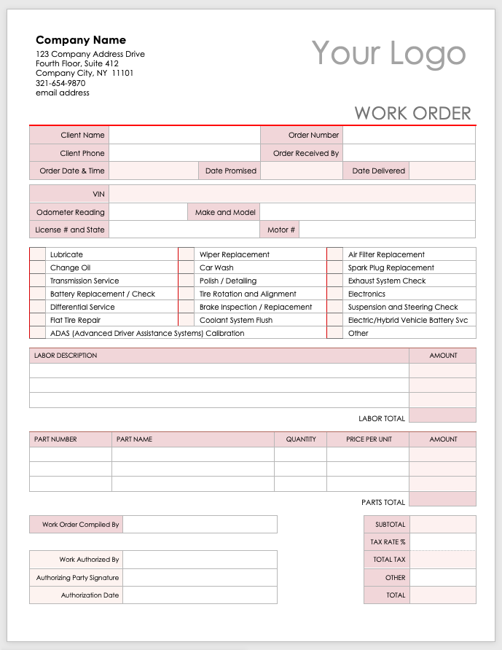

**Company Name**

123 Company Address Drive

Fourth Floor, Suite 412

Company City, NY 11101

321-654-9870

email address

Your Logo

|  |  |  |  |  |  |  |  |  |  |  |  |  |
| --- | --- | --- | --- | --- | --- | --- | --- | --- | --- | --- | --- | --- |
| WORK ORDER | | | | | | | | | | | | |
| Client Name | |  | | | | | | Order Number | | |  | |
| Client Phone | |  | | | | | | Order Received By | | |  | |
| Order Date & Time | |  | | | | Date Promised | |  | | | Date Delivered |  |
|  |  |  |  | |  | | |  | |  |  |  |
| VIN | |  | | | | | | | | | | |
| Odometer Reading | |  | | Make and Model | | |  | | | | | |
| License # and State | |  | | | | | Motor # | |  | | | |

|  |  |  |  |  |  |
| --- | --- | --- | --- | --- | --- |
|  | Lubricate |  | Wiper Replacement |  | Air Filter Replacement |
|  | Change Oil |  | Car Wash |  | Spark Plug Replacement |
|  | Transmission Service |  | Polish / Detailing |  | Exhaust System Check |
|  | Battery Replacement / Check |  | Tire Rotation and Alignment |  | Electronics |
|  | Differential Service |  | Brake Inspection / Replacement |  | Suspension and Steering Check |
|  | Flat Tire Repair |  | Coolant System Flush |  | Electric/Hybrid Vehicle Battery Svc |
|  | ADAS (Advanced Driver Assistance Systems) Calibration | | |  | Other |

|  |  |  |  |  |  |  |  |  |
| --- | --- | --- | --- | --- | --- | --- | --- | --- |
| LABOR DESCRIPTION | | | | | | | | AMOUNT |
|  | | | | | | | |  |
|  | | | | | | | |  |
|  | | | | | | | |  |
|  |  |  |  |  |  |  | LABOR TOTAL |  |

|  |  |  |  |  |  |  |  |  |  |
| --- | --- | --- | --- | --- | --- | --- | --- | --- | --- |
| PART NUMBER | | PART NAME | | | | QUANTITY | PRICE PER UNIT | | AMOUNT |
|  | |  | | | |  |  | |  |
|  | |  | | | |  |  | |  |
|  | |  | | | |  |  | |  |
|  |  |  |  |  |  | |  | PARTS TOTAL |  |

|  |  |  |  |  |  |  |  |  |
| --- | --- | --- | --- | --- | --- | --- | --- | --- |
| Work Order Compiled By | |  | | |  |  | SUBTOTAL |  |
|  |  |  |  |  |  | TAX RATE % |  |
| Work Authorized By | |  | | |  | TOTAL TAX |  |
| Authorizing Party Signature | |  | | |  | OTHER |  |
| Authorization Date | |  | | |  | TOTAL |  |

|  |
| --- |
| **DISCLAIMER**  Any articles, templates, or information provided by Smartsheet on the website are for reference only. While we strive to keep the information up to date and correct, we make no representations or warranties of any kind, express or implied, about the completeness, accuracy, reliability, suitability, or availability with respect to the website or the information, articles, templates, or related graphics contained on the website. Any reliance you place on such information is therefore strictly at your own risk. |