
Microsoft Word
Basic Work Order
Template

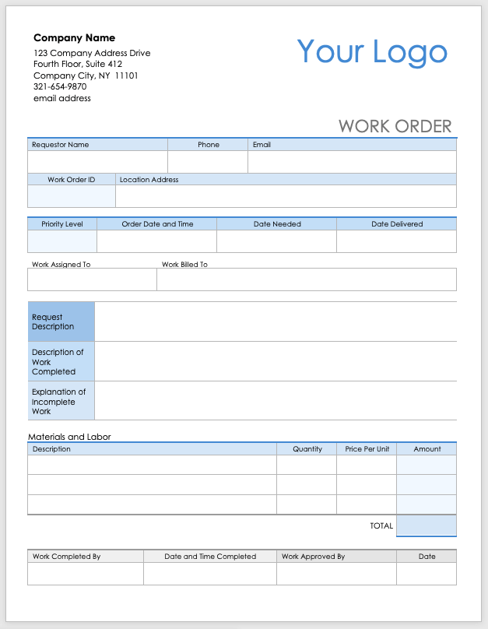
Company Name
123 Company Address Drive
Fourth Floor, Suite 412
Company City, NY 11101
321-654-9870
email address
Your Logo
WORK ORDER
Requestor Name |  | Phone | Email
Work Order ID | Location Address

Priority Level | Order Date and Time |  | Date Needed | Date Delivered
Work Assigned To |  | Work Billed To

Request Description
Description of Work Completed
Explanation of Incomplete Work

Materials and Labor
Description |  |  |  | Quantity | Price Per Unit | Amount
 |  |  |  |  | TOTAL

Work Completed By | Date and Time Completed | Work Approved By | Date

DISCLAIMER

Any articles, templates, or information provided by Smartsheet on the website are for reference only. While we strive to keep the information up to date and correct, we make no representations or warranties of any kind, express or implied, about the completeness, accuracy, reliability, suitability, or availability with respect to the website or the information, articles, templates, or related graphics contained on the website. Any reliance you place on such information is therefore strictly at your own risk.

