
Document Version
Control Template
Blank template begins on page 2.

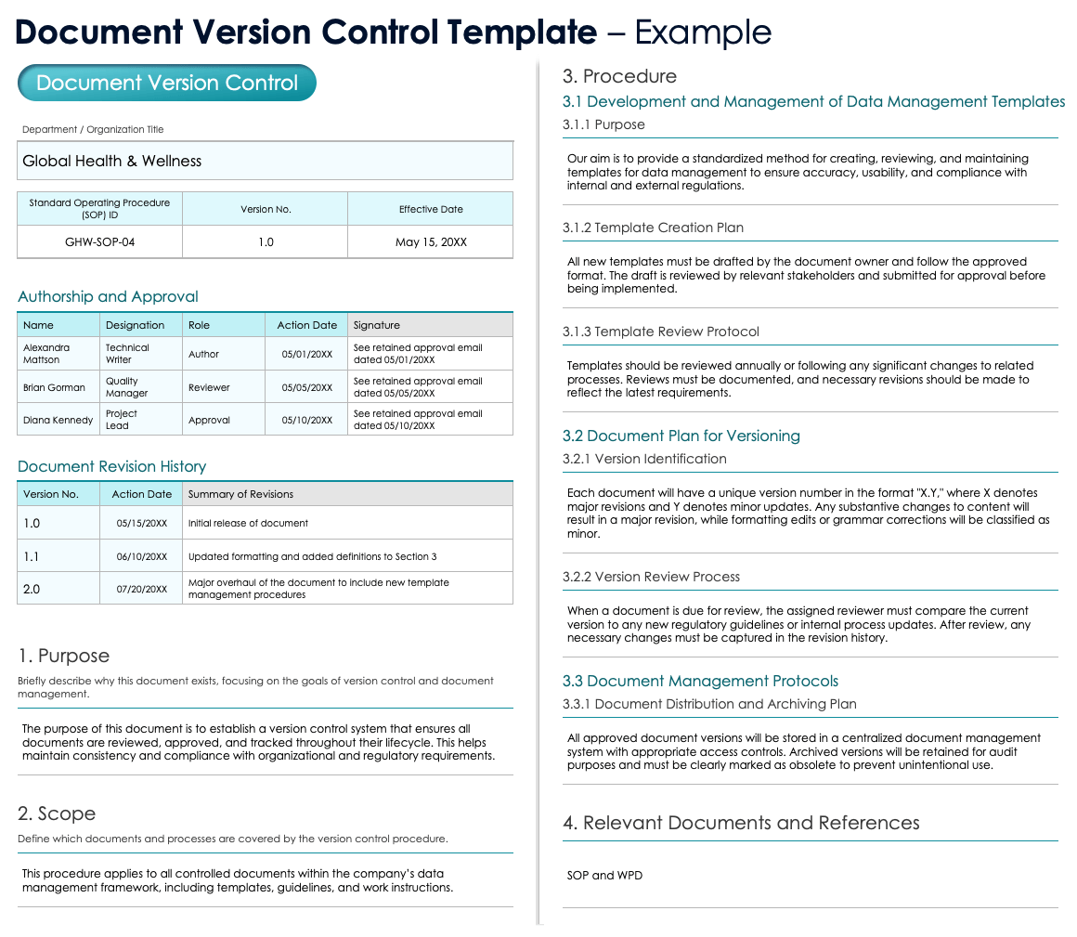

Document Version Control

Department / Organization Title
Standard Operating Procedure (SOP) ID |  | Version No. |  | Effective Date

Authorship and Approval
Name | Designation | Role | Action Date | Signature

Document Revision History
Version No. | Action Date | Summary of Revisions

1. Purpose
Briefly describe why this document exists, focusing on the goals of version control and document management.
Text

2. Scope
Define which documents and processes are covered by the version control procedure.
Text

3. Procedure

3.1 Development and Management of Data Management Templates

3.1.1 Purpose
Explain the goal of developing and maintaining templates, ensuring they meet organizational needs and compliance guidelines.
Text

3.1.2 Template Creation Plan
Outline the process for creating new templates, including responsibilities and review requirements.
Text

3.1.3 Template Review Protocol
Describe how and when templates should be reviewed, and what actions are taken when revisions are needed.
Text

3.2 Document Plan for Versioning

3.2.1 Version Identification
Explain the method for assigning version numbers to documents, including major and minor revisions.
Text

3.2.2 Version Review Process
Detail the steps required for reviewing a document version and maintaining alignment with current standards and updates.
Text

3.3 Document Management Protocols

3.3.1 Document Distribution and Archiving Plan
Describe the process for distributing, archiving, and labeling documents, including ensuring obsolete documents are not used.
Text

4. Relevant Documents and References
SOP and WPD

DISCLAIMER

Any articles, templates, or information provided by Smartsheet on the website are for reference only. While we strive to keep the information up to date and correct, we make no representations or warranties of any kind, express or implied, about the completeness, accuracy, reliability, suitability, or availability with respect to the website or the information, articles, templates, or related graphics contained on the website. Any reliance you place on such information is therefore strictly at your own risk.

