**](https://www.smartsheet.com/try-it?trp=12265&utm_source=template-word&utm_medium=content&utm_campaign=Sample+Music+Event+Sponsorship+Proposal-word-12265&lpa=Sample+Music+Event+Sponsorship+Proposal+word+12265)**

**Microsoft Word Music Event   
Sponsorship Proposal Template Example**

Sponsorship Proposal for

**HarmonyFest 20XX: Celebrating Global Sounds**

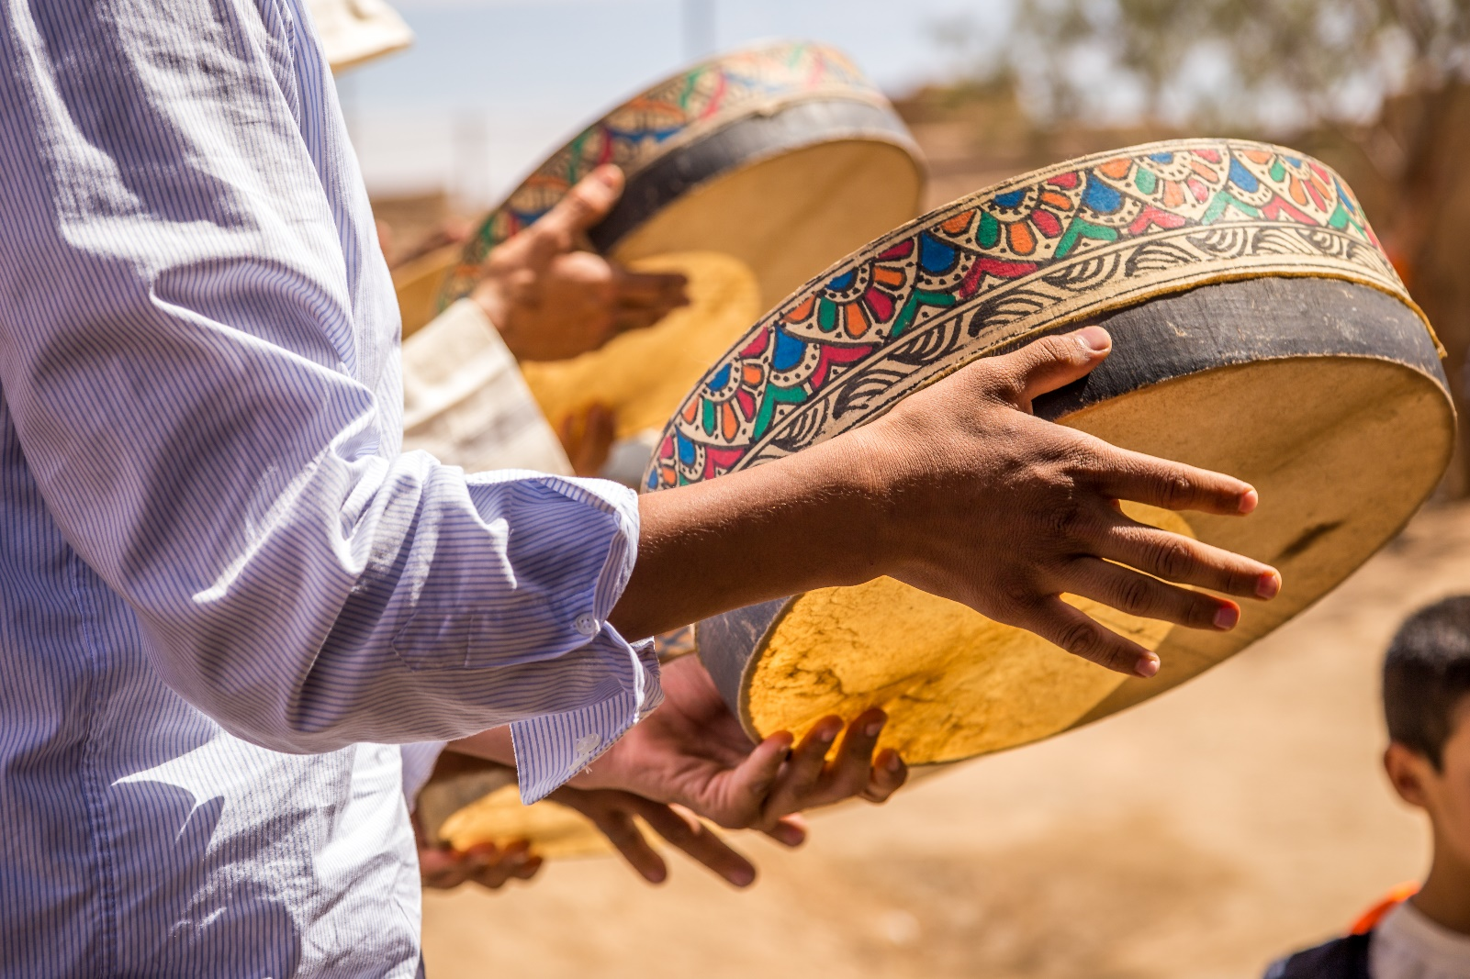

|  |  |  |
| --- | --- | --- |
| Prepared By |  | Date |
| Marta Hicks | | 11/15/20XX |

**table of contents**

**1.** **Introduction** 3

**2.** **About the Event** 3

**3.** **Sponsorship Opportunities** 3

**4.** **Benefits of Sponsoring** 3

**5.** **Sponsorship Packages** 4

**6.** **Custom Sponsorship Opportunities** 5

**7.** **Marketing and Promotion Plan** 5

**8.** **Music and Fan Engagement Opportunities** 5

**9.** **Previous Event Successes and Testimonials** 6

**10.** **Contact Information** 6

|  |  |
| --- | --- |
| **Introduction** | Thank you for considering this sponsorship proposal for **HarmonyFest 20XX,** a vibrant music event showcasing diverse musical genres worldwide. This proposal outlines how your partnership will elevate the event while offering your brand unparalleled exposure and engagement with a multicultural, music-loving audience. |

|  |  |
| --- | --- |
| **About the Event** | **HarmonyFest 20XX** is a three-day music festival scheduled for **July 12–14, 20XX**, at the **SunWave Amphitheater** in **Portbridge, CA**. With an expected attendance of over **20,000 music enthusiasts**, the festival will feature a lineup of international and local artists, interactive workshops, and cultural performances. **HarmonyFest** bridges communities through music, celebrating global sounds and fostering connections among diverse audiences. |

|  |  |
| --- | --- |
| 1. **Sponsorship Opportunities** | Sponsors can select from a range of high-impact opportunities, including:   * **Main Stage Sponsorship**: Branding on the main performance stage for maximum visibility * **VIP Lounge Branding**: Exclusive sponsorship of the VIP area with custom decorations * **Digital Branding**: Logos featured on event websites, social media, and streaming promotions * **Interactive Booths**: Set up experiential spaces for direct interaction with festival-goers |

|  |  |
| --- | --- |
| 1. **Benefits of Sponsoring** | Sponsoring **HarmonyFest 20XX** offers:   * **Widespread brand exposure** through logos on stage backdrops, promotional materials, and digital advertising * **Direct engagement** with an international, diverse audience that values culture and community * **Positive brand association** with creativity, inclusivity, and global unity * **Media mentions** in event coverage from outlets such as **CulturalVibe Weekly** and **MelodyLine Reports** |

|  |  |
| --- | --- |
| 1. **Sponsorship Packages** | This section details the sponsorship packages available for **HarmonyFest 20XX**. Each tier meets various brand objectives, from immersive VIP experiences to broad digital recognition. Our flexible sponsorship levels ensure your company receives value-aligned visibility and meaningful engagement. |
| **Diamond Suit with solid fillPlatinum** Sponsorship  Package | |
| The platinum package includes title sponsorship of the main stage, exclusive logo placement on event tickets and signage, co-branded press releases, 30 VIP passes, including all-access passes for backstage tours, artist meet-and-greets, social media campaign features, and exclusive shout-outs during artist performances. | |
| **Diamond Suit with solid fillGold** Sponsorship  Package | |
| The gold package includes sponsorship of a secondary stage, significant logo placement in marketing materials, press announcement mentions, 20 VIP tickets, special access to artist interaction areas, and email newsletter highlights sent to festival subscribers. | |
| **Diamond Suit with solid fillSilver** Sponsorship  Package | |
| The silver package includes logo placement on the event website, event schedule, select printed materials, a branded exhibit booth, 10 complimentary general admission tickets, and recognition in post-event highlights shared on social platforms. | |
| **Diamond Suit with solid fillBronze** Sponsorship  Package | |
| The bronze package includes logo placement in the event program, social media post mentions, five general admission tickets, and acknowledgment during the opening ceremony. | |

|  |  |
| --- | --- |
| 1. **Custom Sponsorship Opportunities** | We offer custom sponsorship packages that align with your unique marketing goals. Options include co-sponsoring music workshops, branded merchandise collaborations, or exclusive afterparties. These tailored opportunities ensure maximum alignment with your brand objectives and deeper attendee engagement. |

|  |  |
| --- | --- |
| 1. **Marketing and Promotion Plan** | The promotional strategy for **HarmonyFest 20XX** includes:   * **Comprehensive social media campaigns** with targeted ads and countdowns * **Collaborations with influencers** and music bloggers for added reach * **Press releases** sent to **MelodyLine Reports** and **GlobalRhythm Insights** to amplify event visibility * **Post-event recaps** featuring sponsor highlights across digital channels |

|  |  |
| --- | --- |
| 1. **Music and Fan Engagement Opportunities** | **HarmonyFest 20XX** offers sponsors unique opportunities to engage directly with attendees, creating memorable brand connections. Engagement opportunities can include:   * **Interactive Sponsor Booths:** Create branded spaces where fans can participate in activities, games, or sampling experiences that align with your brand identity. * **Exclusive Meet-and-Greets:** Co-host special sessions with artists where attendees can interact, take photos, and receive autographed merchandise, positioning your brand as a key contributor to these exclusive experiences. * **Branded VIP Lounges:** Offer VIP attendees an enhanced experience with branded seating areas featuring sponsor-driven decor, refreshments, and music playlists that resonate with your company’s image. * **Fan Competitions and Giveaways:** Run sponsor-branded contests with prizes such as event tickets, exclusive merchandise, or access to private performances. * **Live Social Media Features:** Collaborate on live-streamed moments during the event that highlight your brand, including artist interviews and behind-the-scenes glimpses shared on event social media platforms. |

|  |  |
| --- | --- |
| 1. **Previous Event Successes and Testimonials** | Our most recent event, **UnityBeat Live 20XX**, welcomed **15,000 attendees** and gained coverage from **MelodyLine Reports** and **VibrantTunes Digest**. **HarmoniCo.**, a previous sponsor, stated, “Partnering with GlobalSound Collective brought us excellent brand exposure and helped us connect with a music-loving community passionate about inclusivity.” |

|  |  |
| --- | --- |
| 1. **Contact Information** | For sponsorship inquiries, please contact: **Aviv Perez** Sponsorship Manager, **GlobalSound Collective** Email: **aviv.perez@globalsoundcollective.org** Phone: **(555) 674-8901** |

Document Sign-Off

## 

|  |  |  |
| --- | --- | --- |
| Prepared By |  |  |
| Marta Hicks | | |

|  |
| --- |
| Reviewed By |
| Makara Mclean | |

|  |
| --- |
| Approval |
| Raghu Prakash | |

|  |
| --- |
| **DISCLAIMER**  Any articles, templates, or information provided by Smartsheet on the website are for reference only. While we strive to keep the information up to date and correct, we make no representations or warranties of any kind, express or implied, about the completeness, accuracy, reliability, suitability, or availability with respect to the website or the information, articles, templates, or related graphics contained on the website. Any reliance you place on such information is therefore strictly at your own risk. |