
Scrum Board Template with Burndown Chart
Project Name: Name |
Date: MM/DD/YY
Sprint Timeline: MM/DD/YY – MM/DD/YY
User Story | Story Points | Assigned To | Priority | Status | Day 1 |  | Day 2 |  | Day 3 |  | Day 4 |  | Day 5
 |  |  |  |  | Estimated Hours | Actual  Hours | Estimated Hours | Actual  Hours | Estimated Hours | Actual  Hours | Estimated Hours | Actual  Hours | Estimated Hours | Actual  Hours
User Story #1 | 8
Task |  | Name | Needs Attention | Complete | 5 | 6 | 4 | 2 | 3 | 0.5 | 2 | 0 | 1 | 0
Task |  | Name | Delayed or Blocked | In Progress | 7 | 4 | 6 | 1 | 5 | 3 | 4 | 0 | 3 | 1
Task |  | Name | Moving Smoothly | Not Started | 0.5 | 5 | 0 | 1 | 3 | 2 | 0 | 0 | 1 | 0
Task |  |  |  | Needs Review | 1 | 2 | 2 | 1 | 3 | 3 | 1 | 1 | 1 | 0
User Story #2 | 1
Task |  |  |  | Approved | 3 | 2 | 0.5 | 1 | 0.5 | 0 | 0 | 0.5 | 3 | 0
Task |  |  |  | Overdue | 5 | 1 | 5 | 3 | 1 | 0 | 1 | 0.5 | 0 | 1
Task |  |  |  | On Hold | 2 | 2 | 5 | 3 | 0 | 2 | 1 | 0.5 | 0 | 0
Task |  |  |  |  | 5 | 2 | 9 | 5 | 5 | 3 | 1 | 0 | 0 | 0
User Story #3 | 5
Task |  |  |  |  | 6 | 4 | 0 | 0 | 0 | 0.5 | 0 | 0 | 2 | 0
Task |  |  |  |  | 1 | 1 | 3 | 1 | 3 | 1.5 | 3 | 4 | 0 | 0
Task |  |  |  |  | 1 | 1 | 0.5 | 0 | 0.5 | 0.5 | 1 | 0.5 | 0 | 1
Task |  |  |  |  | 0.5 | 0 | 0 | 2 | 0 | 0 | 0 | 0 | 0.5 | 0
User Story #4 | 8
Task |  |  |  |  | 4 | 3 | 2 | 1 | 2 | 2 | 1 | 0 | 1 | 1
Task |  |  |  |  | 6 | 2 | 3 | 2 | 3 | 1 | 3 | 1 | 1 | 1
Task |  |  |  |  | 2 | 1 | 8 | 6 | 8 | 7 | 1 | 1 | 0 | 0
Task |  |  |  |  | 0.5 | 0 | 0.5 | 0 | 0.5 | 0.5 | 0 | 0 | 0 | 0
User Story #5 | 3
Task |  |  |  |  | 1 | 0 | 1 | 4 | 1 | 0.5 | 0.5 | 0 | 1 | 1
Task |  |  |  |  | 6 | 5 | 6 | 3 | 0.5 | 0.5 | 3 | 2 | 6 | 9
Task |  |  |  |  | 9 | 6 | 9 | 7 | 4 | 3 | 3 | 1 | 5 | 3
Task |  |  |  |  | 0.5 | 0 | 0.5 | 1 | 1 | 0.5 | 0.5 | 0 | 0 | 0
TOTAL |  |  |  |  | 66 | 47 | 65 | 44 | 44 | 31 | 26 | 12 | 25.5 | 18

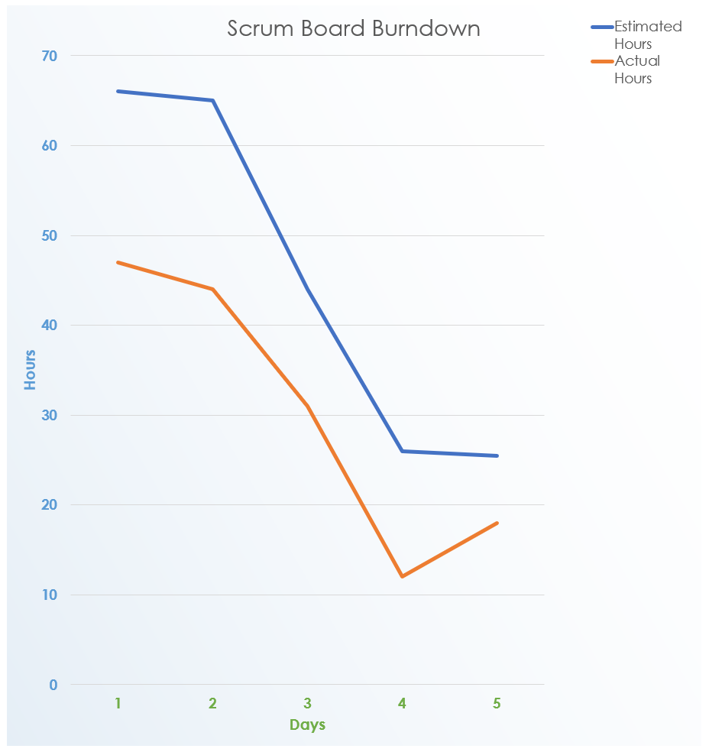
Use the Scrum Board Template with Burndown Chart in Excel to enter data that will populate the charts and graphs for your document. Place a screenshot of your line chart on this page to illustrate your Scrum Board data.

DISCLAIMER

Any articles, templates, or information provided by Smartsheet on the website are for reference only. While we strive to keep the information up to date and correct, we make no representations or warranties of any kind, express or implied, about the completeness, accuracy, reliability, suitability, or availability with respect to the website or the information, articles, templates, or related graphics contained on the website. Any reliance you place on such information is therefore strictly at your own risk.

