**](https://www.smartsheet.com/try-it?trp=12296&utm_source=template-word&utm_medium=content&utm_campaign=Music+Event+Sponsorship+Proposal-word-12296&lpa=Music+Event+Sponsorship+Proposal+word+12296)**

**Microsoft Word Music Event   
Sponsorship Proposal Template**

Sponsorship Proposal for a

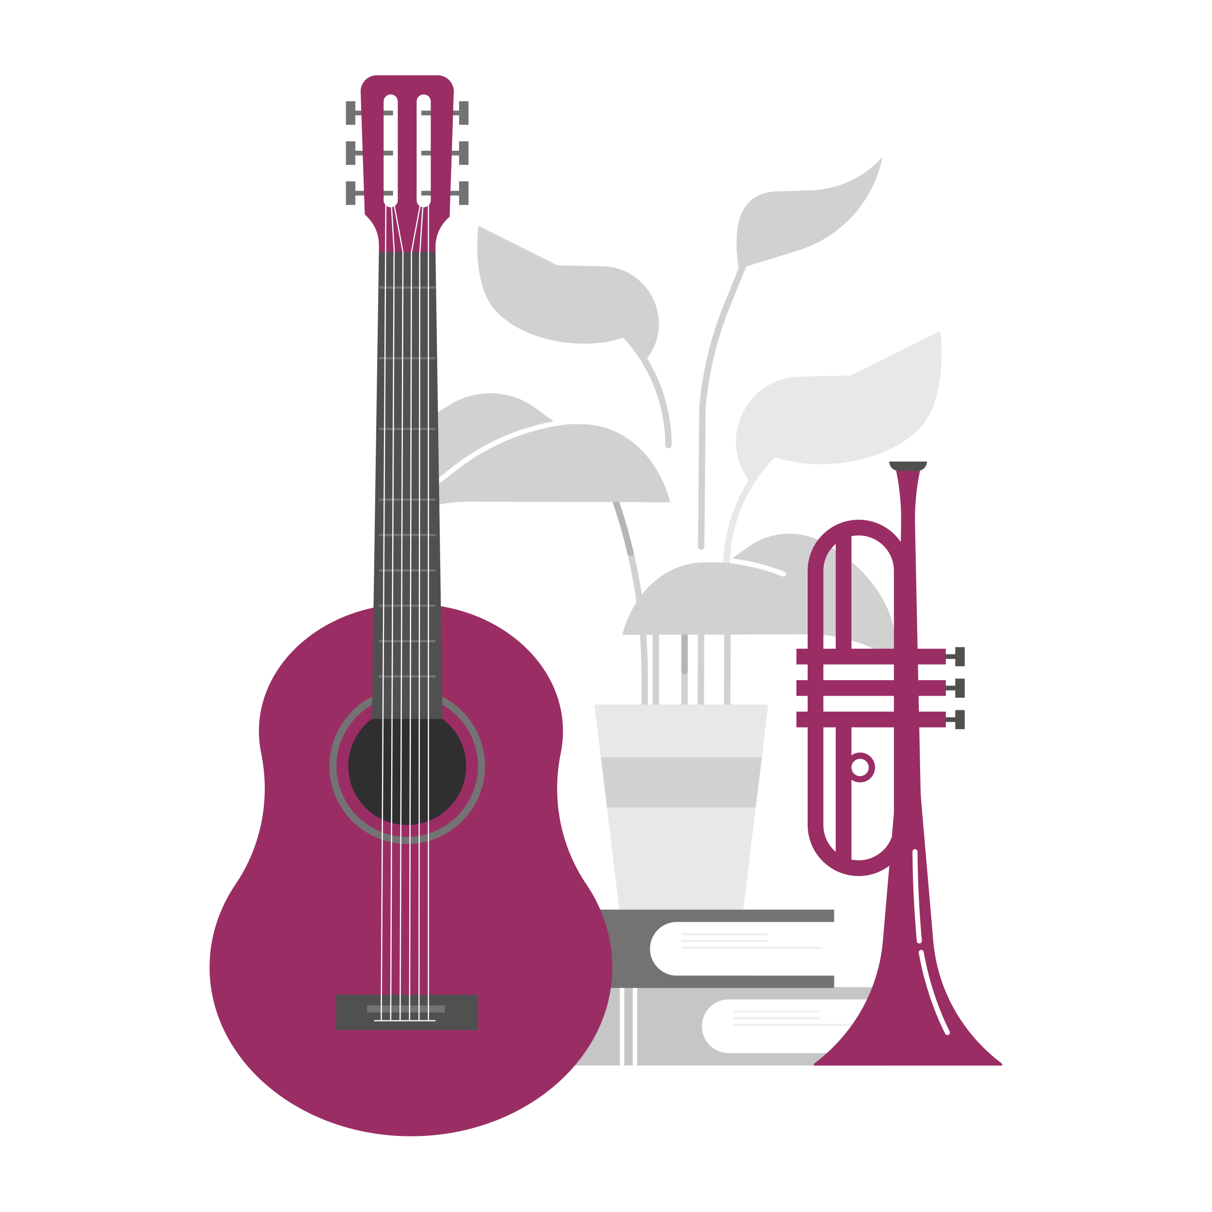**Music Event**

|  |  |  |
| --- | --- | --- |
| PREPARED BY |  | DATE |
|  | | MM/DD/YY |

**table of contents**

**1.** **Introduction** 3

**2.** **About the Event** 3

**3.** **Sponsorship Opportunities** 4

**4.** **Benefits of Sponsoring** 4

**5.** **Sponsorship Packages** 5

**6.** **Custom Sponsorship Opportunities** 6

**7.** **Marketing and Promotion Plan** 6

**8.** **Music and Fan Engagement Opportunities** 7

**9.** **Previous Event Successes and Testimonials** 7

**10.** **Contact Information** 7

|  |  |
| --- | --- |
| **Introduction** | Provide a brief overview of the proposal, including its purpose. Highlight the mutual benefits of the partnership between the event and the potential sponsor. |

|  |  |
| --- | --- |
| **About the Event** | Describe the event in detail, including its mission, objectives, and audience. Include information regarding the event date, location, and expected attendance. Highlight unique event aspects that make it an attractive opportunity for sponsors. |

|  |  |
| --- | --- |
| 1. **Sponsorship Opportunities** | Outline the assorted opportunities available to sponsors, including branding, speaking opportunities, exhibit space, and any digital or physical presence associated with the event. |

|  |  |
| --- | --- |
| 1. **Benefits of Sponsoring** | Describe the value proposition for sponsors, detailing how sponsoring the event will benefit them. In this statement, you can discuss brand exposure, direct access to potential customers, association with values or causes, and opportunities for engagement and interaction with the audience. |

|  |  |
| --- | --- |
| 1. **Sponsorship Packages** | Detail the available sponsorship packages. Include the benefits associated with each level of sponsorship. Typical tiers might include Platinum, Gold, Silver, and Bronze, with corresponding benefits like logo placement, promotional opportunities, and VIP access. |
| **Diamond Suit with solid fillPlatinum** Sponsorship  Package | |
| Describe the highest-level benefits that provide maximum exposure and exclusivity. | |
| **Diamond Suit with solid fillGold** Sponsorship  Package | |
| Describe the second-highest benefits that offer strong brand visibility and engagement opportunities. | |
| **Diamond Suit with solid fillSilver** Sponsorship  Package | |
| Highlight mid-tier benefits that include moderate visibility and interactive opportunities. | |
| **Diamond Suit with solid fillBronze** Sponsorship  Package | |
| Provide details on entry-level benefits that offer basic brand visibility. | |

|  |  |
| --- | --- |
| 1. **Custom Sponsorship Opportunities** | Offer sponsors the opportunity to create a custom package that fits their marketing goals and budget. Highlight your flexibility and willingness to collaborate on unique sponsorship activations. |

|  |  |
| --- | --- |
| 1. **Marketing and Promotion Plan** | Summarize your marketing and promotional efforts for the event, emphasizing how you will feature sponsors. This plan can include social media campaigns, email marketing, press releases, and advertising efforts. |

|  |  |
| --- | --- |
| 1. **Music and Fan Engagement Opportunities** | Describe how sponsors can engage with fans during the event, including branded activations such as interactive booths, product giveaways, or sponsored fan zones. For example, sponsors might provide charging stations, exclusive merchandise, or VIP experiences that enhance the fan experience. |

|  |  |
| --- | --- |
| 1. **Previous Event Successes and Testimonials** | Share highlights and successes from previous events, including statistics like attendance numbers, social media engagement rates, and any notable media coverage. Include testimonials from past sponsors and attendees to underscore the value and impact of the event. |

|  |  |
| --- | --- |
| 1. **Contact Information** | Include detailed contact information for the event’s sponsorship coordinator or the person responsible for managing sponsor relationships. |

Document Sign-Off

## 

|  |  |  |
| --- | --- | --- |
| Prepared By |  |  |
| Name | | |

|  |
| --- |
| Reviewed By |
| Name | |

|  |
| --- |
| Approval |
| Name | |

|  |
| --- |
| **DISCLAIMER**  Any articles, templates, or information provided by Smartsheet on the website are for reference only. While we strive to keep the information up to date and correct, we make no representations or warranties of any kind, express or implied, about the completeness, accuracy, reliability, suitability, or availability with respect to the website or the information, articles, templates, or related graphics contained on the website. Any reliance you place on such information is therefore strictly at your own risk. |